Table 1

Figure 1 Figure 2
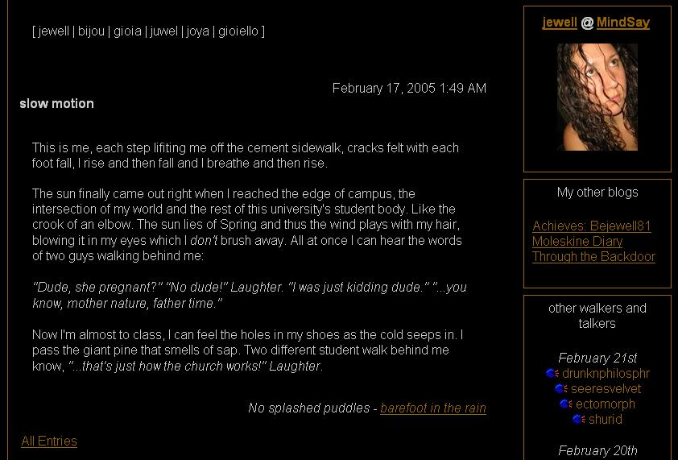
Figure 3 Figure 4

