Overview

Rollovers are images that as visual appeal to a website and act as a way to communicate how to navigate a site. The Rollover changes when the user’s mouse moves over the image and acts as a cue that the image is a link and can navigate the user to another are of the website. Rollovers are not written in standard HTML (<link) but are written in JavaScript (<link.) You will be using Fireworks to create the images and Dreamweaver MX to create the Rollover. Dreamweaver will automatically write the rollover in JavaScript.

Rollovers require two graphs: an “off” state and an “on” state. You will creat both these graphs in Firefox before moving to Dreamweaver to make the actually Rollover.

What you need to know to create a Rollover image:

How to save files in Dreamweaver and Fireworks, how to open files in DW and FW, know where to locate the Properties toolbar on Fireworks and Commons toolbar on Dreamweaver.

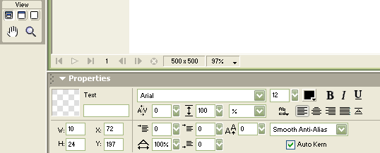

Above is a screenshot of the Properties toolbar you will be using to create your two graphs for the Rollover image.

Task 1: Creating the “on” state graph using Fireworks

Step 1. To begin, open Fireworks and go to File, select New, define Height and Width as 101 X 24, then click Ok.

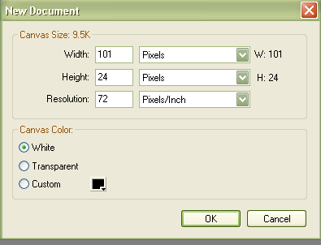

Defining the Height and Width is an important step as it insures that both graphs will be the same size and won’t appear distorted when the Rollover is created.

Step 2. In the Property toolbar, define the X and Y coordinates as 0,0.

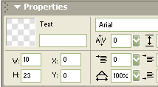

Step 3. Type “contact” into the text box to create the first graph.

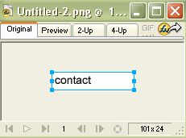
Step 4. Center the text then select color.

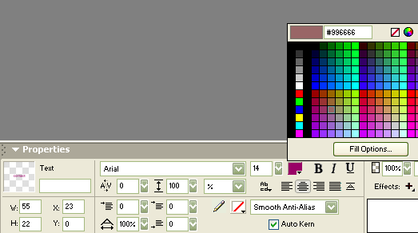

Step 5. Now save the graph by selecting File > Save, save file as “onstate_contact.”

You have just create the first graph for your Rollover image! Now you will create the “off” state graph in Task 2, needed to complete the Rollover.

Task 2 Create “off” state graph for Rollover

To create the “off” state graph you will alter the “on” state graph you already have open. If you do not have the “on” state grapy open, open it now.

Step 1. Once the graph is open, highlight the text “contact” and then change the text color.

Step 2. To save the “off” state graph go to File > Save File As and name the file “offstate_contact.”

You have now created the “on” state graph needed to create your Rollover image.

To create your Rollover Image using the two graphs you just created proceed to Task 3.

Task 3 Creating a Rollover Image

Step 1. To begin, open Dreamweaver MX. Click the Rollover image object in the Common panel.

Step 2. The insert Rollover Image dialog box will appear. Name the image “contact” in the Image Name text box. For the Original Image, click Browse to select onstate_contact.jpg located (where?). For the Rollover Image, click Browse to select offstate_contact.jpg located in the same folder. For Alternative Text type “contact.” For go to URL insert the following: http://www.shibumi.org/eoti.htm

[screen shot of dialog box]

Step 3. Make sure the dialog box matches the dialog box above and then click Ok.

The contact image should appear in your Document Window.

[screen shot of Doc. Window]

Step 4. To preview and test Rollover image click the Preview/Debug drop down menu in the Document Toolbar and select iexplorer to open the document into an internet browser.

The explorer browser window should appear showing you the Rollover image. To test the Rollover, pass you mouse over the image. The Rollover should change from its “on” state to its “off” state as you pass over it. This indicates that you have successfully created a Rollover Image!

