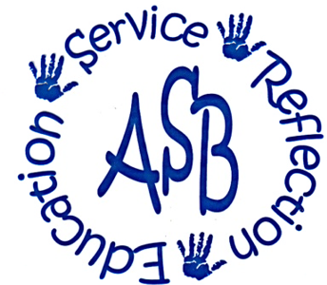
Alternative Spring Break
Grand Valley State University
008 Kirkhof Center
Allendale, MI 49401-9403
Phone (616) 331-3471

-Participant Application-
2005-2006

Name:
Local Address:
Phone #: E-Mail:
Class Standing: [ ] Freshman [ ] Sophomore [ ] Junior [ ] Senior [ ] Senior+
T-Shirt Size:
Major: Minor:

Please return completed applications to the
Student Organization Center in Kirkhof
By 5:00p.m.

WEDNESDAY, November 9, 2005

Spring Break Lasts Seven Days…
Alternative Spring Break Lasts a Lifetime

Mission of AB

Alternative Breaks strives to develop growth and understanding through reflective, hands-on service learning projects, focusing on different social issues throughout the nation on educational breaks from Grand Valley State University.

Participant Expectations
- Full attendance and participation at all ASB events and meetings.
- Commitment to the AB no drug and alcohol policy.
- Abiding by the AB Constitution.
- Remaining flexible, open-minded, and responsible.

Time Commitments
- November 16: AB Orientation, 9pm Grand River Room, KC
- December 2: $75.00 Non-Refundable Deposit Due, OSL
- January 13: $175.00 Final Payment Due, OSL
- January 21: Incredible Journey 9-4pm Grand River Room, KC
- March 4-11: Alternative Spring Break
- April 1-9: School of Education Spring Break
- April 12: Never Ending Journey 9pm Pere Marquette, KC
- Any fundraisers, pre-volunteer, post-volunteer or meetings scheduled by your site leaders.

Do you have any foreseeable conflicts with the above events? If so, which one(s) and why?

*The above listed dates are mandatory for all participants. *

Who Are You?
If someone could describe you in three words, what would they say?
*

*

*
What is one thing YOU feel you could improve on and why?

What Do You Do?
To help us get to know you better, tell us what you are involved in on and off campus. Please include, your major, work, sports, organizations, etc.

Past Experiences
Please list any previous ASB experiences.

Issue Selection
Please choose your top five choices for this year’s issues and provide a brief explanation of why you choose those particular issues. Please choose from the following issues.

* Affordable Housing * Animal Rights
* Cultural Awareness * Disabilities: Building Mobility
* Domestic Violence * Health and Aids
* Hunger and Homelessness *Path Creations
* Native American Culture * River Restoration
* Rural Poverty * Trails
* Wildlife Refuge * Youth and Education
*Youth and Wishes *Youth and Wishes COE

Issue Why?

Are there any issues you would not feel comfortable working with? If so, which one(s)?

If you are applying for the College of Ed trip please just write “COE” under the issue; since there is only 1 trip for the COE trip there is not an option for an issue. The issue with be Youth and Wishes (COE).

What makes you unique?
List three things that make you a unique person.
*

*

*

Short Answer
Considering the expectations placed on participants, why do you want to devote a substantial part of your semester and your spring break to participate in the program? What motivates you to be a participant of ASB?

Is there anything you would like to tell us that you have not had a chance to express?

