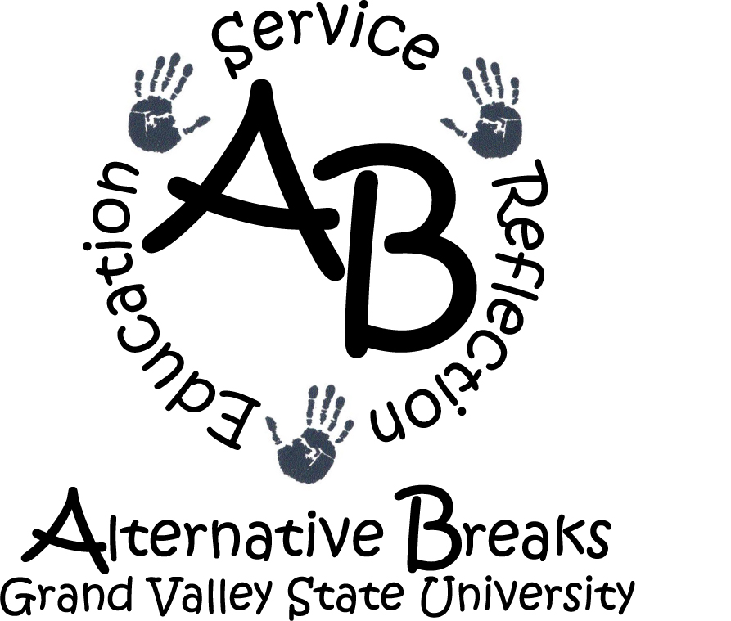
008 Kirkhof Center
Phone (616) 331-3471 Allendale, MI 49401-9403 Fax (616) 331-3797
WINTER BREAK
-Participant Application-
2005-2006

Name:
Local Address:
Phone #: E-Mail:
Class Standing: [ ] Freshman [ ] Sophomore [ ] Junior [ ] Senior [ ] Senior+
T-Shirt Size:
Major: Minor:

Please return completed applications to the
Student Organization Center in Kirkhof
By 5:00p.m.

WEDNESDAY, November 9, 2005

Alternative Winter Break Lasts a Lifetime

Mission of AB

Alternative Breaks strives to develop growth and understanding through reflective, hands-on service learning projects, focusing on different social issues throughout the nation on educational breaks from Grand Valley State University.

Participant Expectations
- Full attendance and participation at all AWB events and meetings.
- Commitment to the AB no drug and alcohol policy.
- Abiding by the AB Constitution.
- Remaining flexible, open-minded, and responsible.

Time Commitments
- November 16: AB Orientation, 9pm Grand River Room, KC
- December 2: $250 Payment Due
- January 2-6: Winter Break
Do you have any foreseeable conflicts with the above events? If so, which one(s) and why?

*The above listed dates are mandatory for all participants. *

Who Are You?
If someone could describe you in three words, what would they say?
*

*

*
What is one thing YOU feel you could improve on and why?

What Do You Do?
To help us get to know you better, tell us what you are involved in on and off campus. Please include, your major, work, sports, organizations, etc.

Past Experiences
Please list any previous Alternative Breaks experiences.

What makes you unique?
List three things that make you a unique person.
*

*

*

Short Answer
Considering the expectations placed on participants, why do you want to devote a substantial part of your semester and your spring break to participate in the program? What motivates you to be a participant of AWB?

