The Disc, LTD.
websolutions usability group
REcommendation report

juliane bildner
daniel pepper
brianna reilly

April 24, 2006

our client & their need
The Disc, a small but professional recording studio located on 9 mile and Beechwood in Eastpointe, Michigan, is owned and managed by Greg Reilly. It was founded by Mr. Reilly over 20 years ago. They have 2 studios with the latest technology and equipment and team of engineers to work with aspiring artists. They also do mastering, CD transfers and CD printing. Their primary purpose is to provide beginning artists with the right equipment and people for a professional quality sound.

The current Web site for The Disc is a very plain and straightforward site that lists prices and attempts somewhat to attract new customers. It is not very attractive. The site’s primary audience is the attraction of new clients, and to convince them that they need the services of this professional studio, with special attention to rap and hip-hop artists.

The Disc’s current Web site looks amateur. It attempts to give a feeling of professionalism while at the same time appearing edgy. There is no real consistency to the different areas of the The Disc’s Web site. There also seems to be no specific aim to the different audiences that might be looking into the The Disc’s services. Insight into what would attract and impress the primary audience most would greatly help this site know what direction to go in. In the past no real emphasis was placed on user needs, and the Web site was created with just the basic goal of having a Web presence. In the future, a more user-attractive site is intended to be produced, with an emphasis on drawing in new clients to the studio and to the recording school.

our research questions
In order to create a professional and effective website for The Disc our research was designed around these five questions:

- What problems do users have with the current Web site?
- How does the current site compare with competitor’s sites?
- What about the current site is effective?
- What about the site does the client want to emphasize?
- What are the primary user goals?

The information gathered from these five questions gave us insight on what was needed to create a thorough recommendation for improvements on their site.

our methods of research
Based on our five research questions we felt the best methods for conducting the research would be to utilize a genre analysis of similar sites, usability testing of both current and potential clients, as well as interviews with employees and administration of The Disc, along with their clientele.

- Genre Analysis (see Appendix A)- Gave us insight on the competition and ideas for a more structured site. The GA also gave us more background into the client type to better help facilitate their needs.

- Usability Testing (see Appendix B)- This was crucial to our research because the user is the focus of the site, it was necessary to gather information on what aspects the users felt were working and aspects that needed to be improved. The testing also helped us understand the user’s perspective.

- Interviews- Conducting interviews with the employees and administration of The Disc gave us a better understanding of their goals and the image they wanted to project through their website as well as establishing the company philosophy. Interviews with The Disc’s clientele supplemented our usability testing allowing them to elaborate more on the successes and tribulations of the website.

what we found
Through our research methods we were able to find answers to our five main questions.

- What problems do users have with the current Web site?
  - The sites navigation needs to be simplified and more consistent
  - The pages need to be consistent throughout the site
  - The site needs a cleaner layout; need to eliminate the “clutter”
  - The site needs to have an overall professional look/feel

- How does the current site compare with competitor’s sites?
  - Through the genre analysis of other recording studios such as Cue Recording, Asylum Studio and Quad Studios we found that although some of them did have cleaner layouts than The Disc, there was a consistent lack of style and professionalism among all of the sites as well as a lack of consistency throughout the pages though. The sites did however have a nice consistent structure for easy navigation from page to page.
(sources: http://www.cuerecording.com/, http://www.asylumstudio.com, http://www.quadstudios.com/flashindex.htm)

- What about the current site is effective?
  - The usability testing revealed that although the content needed better organization, the information presented was useful and fit the needs of the clients.

- What about the site does the client want to emphasize?
  - Interviews with the employees and administration of The Disc showed that their main focus was to project their professional yet edgy appearance and make their services known to potential and current clients.

- What are the primary user goals?
  - Interviews showed that the primary user goals were to obtain contact information, studio pricing, hours of operation, location and services offered.

our recommendations
Based on our findings, we have concluded that the site could be improved in three areas: navigation, organization and design.

navigation recommendations
The navigation bar options need to be more clearly defined so the users can distinguish which link they’re going to.



*Current navigation bar

Currently new users have a problem knowing exactly what the different headings of the links mean. Instead of having “mixing” and “mastering” just as labels these need to be explained, perhaps as an introduction on the page.

Also, each page needs a title so the user would know where they are. A title and intro at the top of each page would make it much easier for a new user to navigate around the site and get a feel for the content of the page.
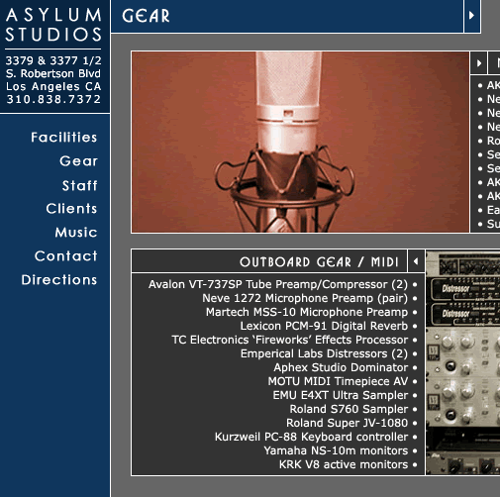

*Recommended navigation bar, http://www.asylumstudio.com

organization recommendations
A more organized layout, with sections grouped to make it clearer for the user would be extremely helpful. Pulling together things such as “CD Duplication” and “mastering” under one large topic such as “Additional Services Offered” would help the potential and current client get to know easily what else The Disc offers besides its recording studios.

Also, since mixing is done within studio time it would make potential clients understand that better by putting that section under the studio rates.

Each section of the site needs to have a consistent structure with the rest of the pages. Currently there is an uneven amount of info on each page with often no introduction to the content of the page.
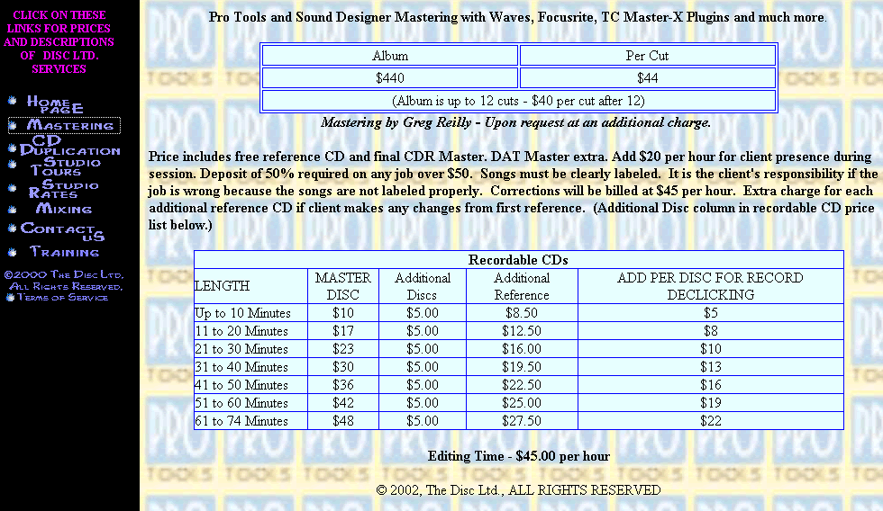

*Current page

Each page needs to have a title and introduction to the content before listing information. This will tell users quickly and easily where they are and whether they want to be there or not.

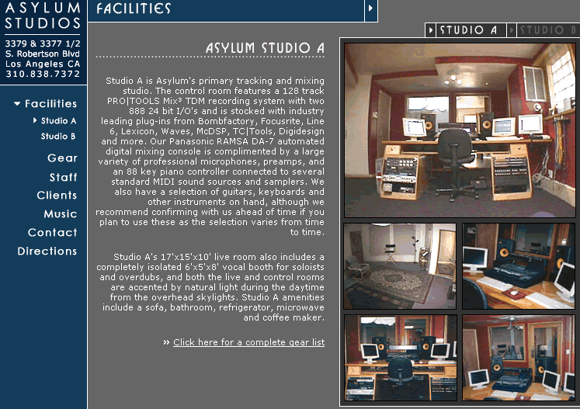

*Recommended page, http://www.asylumstudio.com
Since the goal of this site is to attract potential clients, a section that quickly and simply sums up the best qualities of the studio and why the potential client should record there is suggested.

This would give people who don’t know much about the recording industry but still want to get started a quick look into it. This section should persuade the potential client that it is worth their time and money to record at The Disc.

This could be implemented in one of two ways. One, a Frequently Asked Questions (FAQ) page could be developed, with a link to it from the homepage. Two, this information could be integrated into the homepage, making sure to keep the information simple and clean so as not to clutter the page.

design recommendations
A Flash intro with an interesting opening into the site would help to attract potential clients, such as the one used by http://www.quadstudios.com/flashindex.htm.

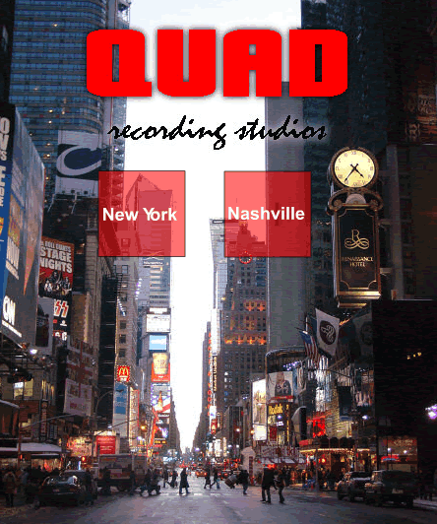

*Recommended opening page #1, http://www.quadstudios.com/flashindex.htm

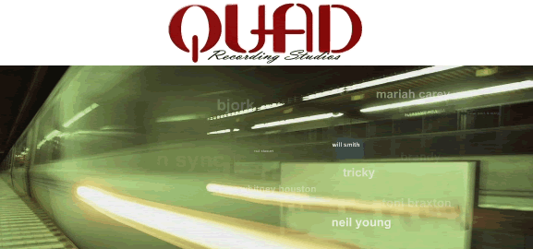

*Recommended opening page #2, http://www.quadstudios.com/NewYork/index2.htm

Flash intros can be designed using Macromedia Flash. These can also be designed and purchased from professionals for a fee if one does not possess the abilities themselves.

A simpler and more understated use of colors would also make the site look more professional.

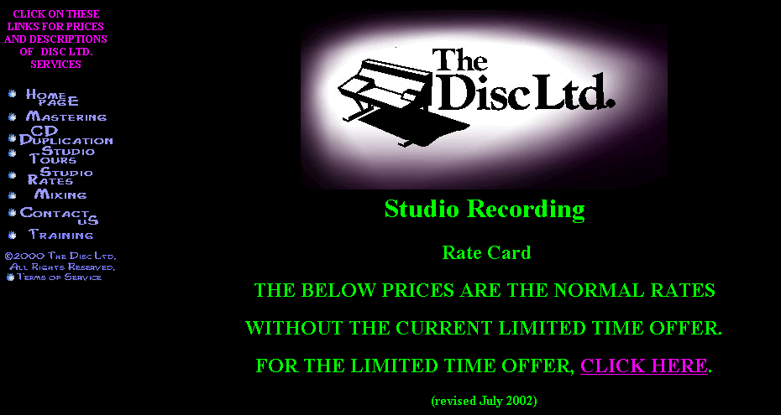

*Current color scheme

We suggest continuing to use a black background, but instead of using several different fluorescent colors, pick a color scheme consisting of two to three colors, and use the scheme throughout the site. To add to the consistency, pick certain levels of the page (title, heading, paragraph) to add the color to, and have that color present in that level on every page.

final thoughts
If time had allowed, we would have created a prototype for The Disc, LTD. that incorporated the recommendations for page navigation, organization and design that would have given the page, as well as the studio, the professional yet hip and edgy image they are trying to portray to their clients.

*Attachments below

appendix A
Genre Analysis

Overview:

In order to fully understand the needs and goals of The Disc Recording Studio, we performed a genre analysis of The Disc’s current website along with websites of similar recording studios.

Audiences & Users:

The primary user groups of websites for business’ such as The Disc are current and potential clients of the recording studio. The clients, both current and potential, frequent the website for studio rates, hours of operation, directions to the studio and as a reference of services offered.
Users also visit these sites for lists of artists, track samples and for pictures of the facilities and their equipment.

Format & Organization:

The Disc’s current website has a very simple layout and design, and the organization of the site’s content is lacking. Although the information is divided into subcategories and there are links to each, the layout and organization of each page has a messy feel. Information seems to be randomly posted on the pages and the links are so close together that it is hard to tell which category you are clicking on.

This lack of organization and poor layout seems to be very consistent among the different sites. Other sites such as have similar problems regarding the layout and organization of the sites content. All of the sites are also lacking in page consistency. Shapes, colors and poor quality images seem to be running rampant on the pages of the studio websites.

Level of Formality:

The level of professionalism that The Disc Recording Studio is trying to portray is not coming through in its current site. The website has a very amateur look to it and needs a great deal of help in building a professional image on the internet. It’s not just this site however; the other recording studios seem to have the same problem here as well. Some of the websites may have a very attractive and professional looking homepage, but as soon as you enter the site it has the same “1990’s” theme going that The Disc has.

Visual Cues & Images:

The overall looks of The Disc’s current website as well as the websites of the other studios look amateur and out of date. They have terrible color schemes from page to page and lack in consistency. The image quality is fairly poor for the most part and the text on the pages is hard to read due to poor font choices. The website needs to be updated and rescued from 1991!

Range of Variation:

The Disc’s website doesn’t seem to vary much from the other studios. All of the websites seemed to be geared toward their clients and the content and information on the sites was very similar as well. Some of the other studios included things like lists and track samples from current and former clients that The Disc does not offer to its users on their current website.

Forecast:

TheDisc.com is in need of a total makeover. The pages need to be more consistent in the areas of layout and design and the overall quality of the sites images and content organization needs to be improved. With the ideas and information gathered from this analysis, WebSolutions should be able to bring The Disc Recording Studios into the .com era with a professional look and feel.

appendix B
Usability Test Plan for The Disc Website

Purpose

The main purpose of this test is to predict the expected performance of a user visiting the current web pages and to remedy serious problems. The test will determine whether the web site can help users to accomplish their user goals when they visit this site: quickly and easily navigate through relevant information regarding The Disc, including studio pricing, hours, contact information and location.
Problem Statements

- Can users navigate the web pages easily?
- Can users find the information about The Disc in a timely manner?

User Profile

We will be testing current and potential clients of The Disc.

Method (test design)

Participant greeting
- Each participant will be tested individually.
- They will be seated in front of the computer and the two usability testers will present. One is to administer the test and the other is to watch the performance of the test subjects and take notes.

Performance Test
- Participants will be given oral instructions for tasks.
- Participants will be asked questions related the website and hoped to find answers by searching the degrees web pages.
- Testers may answer questions that will not affect the outcome of the test and that will not give hints to the participants.

PARTICIPANT DEBRIEFING
- Following the test, participant will answer questions concerning their previous experience they just have had.
- Questions will be open-ended and we are looking forward to hearing suggestions from participants.

Task List

Task #1- Performance Data: Navigation of the website
- Go to the homepage.
- Find information for “Studio Rates”. (Q: Can you find the cost of a 6 hour block in studio A during the day?)
- Find information for “Location” and “Contact Info”. (Q: Can you find where The Disc is located?” Q: Can you find the bosses email address?)
- Return to the homepage.

Task #2- Opinions Data: Reflection of the website
In this task, we will ask participants a series of questions concerning their impressions of the website.
Q1: Was the organization of the site clear or confusing? Please elaborate.
Q2: Discuss the navigation aids. Were they easy to use, clearly marked, easy to find? Did you find any that didn't work?

Q3: Were the graphic components of this site helpful or confusing? Why?

Q4: Please describe the mood, tone, or feel of the web site. You might describe it by using adjectives or by comparing it to landscape, weather or food.

Test Environment/Equipment
The test will take place at The Disc.

