Websolutions Recommendation Report

RHA Website

Andrew Peterson
Erica Eash
Adrienne Brockhaus

Due April 24, 2006
The Client and the Need

RHA stands for Residence Housing Association. It is a student-run group that works as a liaison organization between Grand Valley's residents and the housing administration.

RHA is made up of 12 community councils (C.C.s - one for each Grand Valley housing community) and is overseen by an executive board. C.C.s host community events as well as community general assembly meetings where resident are encouraged to bring their housing concerns. Those concerns are then relayed to RHA at weekly general assembly meetings which are overseen by the RHA executive board. RHA works with the housing administration to provide additional funding to community councils when needed. In addition RHA also puts on larger campus events.

As a complex organization RHA has to provide pertinent information to a variety of different audiences. The most logical way for RHA to provide this information is through their website. However, poor organization and upkeep have prevented RHA's website from becoming a cornerstone of the organization. Furthermore, the site is purely informational and not at all promotional, a fact which currently limits the site's potential user base.

Research Questions
The following questions are the key points of focus the researchers used to better understand what needed to be done to improve and redesign Grand Valley’s RHA website. Each question was investigated through various means which are outlined in the methods section of this report.

- What are our target groups?
- What do general users use the website for?
- How often do general users visit the website?
- What do general users like/dislike about the website?
- What do website administrators wish the site provided?
- What info would users who are not familiar with RHA be hoping to find?

Methods
Each of the research questions above was investigated thoroughly via several different means. The following methods are outlined to better give an understanding of how the data was gathered.

Genre Analysis
By conducting a genre analysis of similar RHA websites from universities across the United States, a better understanding can be gained about what elements should be included in Grand Valley State University’s own RHA website. The most widely used and most effective elements present in other RHA websites can be teased apart into categories such as design, structure, layout, visuals, navigation and so forth. Once this is done, a broad and basic list of requirements can be drawn up of what should be included or excluded from the redesign of Grand Valley State University’s RHA website.

This genre analysis was conducted by visiting the RHA sites of Seattle University, Pacific University, the University of Alabama, Cornell University and St. Louis University. These pages were selected as they are from various locations across the United States, they all have identical target groups and goals and each page has effective designs which Grand Valley’s RHA page could feasibly adopt.

Surveys
The second analysis was based on surveys that were handed out to RHA general assembly and executive board members. These surveys strove to ascertain the common uses for the current website as well as any navigation problems experienced by frequent users. Data was collected from around 20 respondents who were in attendance at the RHA general assembly meeting.

Usability Tests
Usability tests were conducted amongst non-users and users of the RHA website (current RHA members). Navigational scenarios were given in order to see whether or not the user could find the information requested on the RHA website. The scenarios focused upon basic information that, with the help of the genre analysis, seemed as though it should be on the website as it is information found on other RHA websites.

Findings
With these research methods, the following information was gathered. Here the data has been divided according to the methods with which it was gathered.

Genre Analysis Findings
The primary elements that this genre analysis focused on were design/style, navigation, visuals and layout/structure. Each of these elements is required in the building of a functional and attractive website.

Users
- Prospective students or future users of campus housing are the primary users of RHA websites
- Officers and members of the RHA itself also typically use the sites to familiarize themselves with upcoming events and so forth

Style/Design:
- Above all, the best designs are as simple as possible
- The site must be strongly designed around the college’s theme. i.e. school colors, logo, and layout
- The RHA site must be instantly identifiable as part of GVSU based on design alone
- Each page within the RHA site should use the exact same layout and design as the home page—must be uniform!

Navigation:
- Left-side navigation bar including: “About Us”, “What is RHA?”, “Upcoming Events”, “Campus Housing”, “Officers” and “Links”
- A quick link back to the RHA home page and the GVSU homepage must be available
- Users must be able to easily identify where they are within the website and where they have been already—however, the smaller and less complex the website, the less this becomes and issue
- Because of the simple layout, Forward and Back buttons are not needed
- Furthermore, a page scroll across the bottom is not needed

Visual:
- A picture gallery of the available housing at GVSU
- A picture gallery of the RHA officers
- The overall visual style of the site should mirror that of GVSU’s home page. i.e. the same logo, color scheme and so forth
- Each page within the website may contain its own unique image or graphic as well to give each page a hint of uniqueness

Layout:
- As simple as possible
- The navigation bar should run down the left hand side of the page
- The University’s logo/title bar should run across the top of the page
- The main text of the page should be set aside from the navigation bar and title bar with a plain white background.

Survey Findings
The survey issued to general assembly members at the RHA meeting focused on addressing who visits the RHA website, what they are looking for, and what could be improved or fixed. The following findings have been divided into the research questions that have been answered with the data gathered.

What Information Do Current Users Gather from the Site?
- Documents
- The RHA Constitution: Amendments are constantly being made to the RHA constitution and so access to it is important to active members. Many interview respondents also noted that access to proposed bills/legislation would also be helpful.
- OTMs: RHA members can nominate other members for regional/state/national "Of The Month" awards. Specific forms are required for this.
- Meeting Minutes: RHA members use the minutes to double check times and dates which are announced during the general assembly meeting. Minutes are typically emailed out to active members only.
  - Contact Information
- For RHA executive board members
- For C.C. members
- For RHA advisors
  - Dates
- Dates for community council and RHA programs
- Due-dates for OTM forms and conference applications

What Kind of Users Could Benefit from the Site?
- Community council members
- RHA executive board members
- Residents curious about RHA

What Do Current Users Believe Would Improve the Site?
- Regular updating
- Easier navigation
- Better organization
- Overall better appearance

Usability Testing Findings
Usability Testing was conducted in order to create scenarios in which the user was challenged to find specific information from the RHA website. These questions were developed based upon basic information that should be found on the RHA website, some of which was found to be inaccurate or not present at all. The following information represents that which was gathered during the usability testing amongst new users (those unfamiliar with the site) and RHA members.

New Users
Scenario 1: Find meeting times
Results: Although the user was able to easily find meeting times, those meeting times were incorrect. The website needs to be updated.
Scenario 2: Find events for the month of April
Results: Events listed were out-dated (from November), and focused on current RHA members. Events put on by RHA (instead of for RHA) were not promoted.
Scenario 3: Find contact information for the organization
Results: The user was easily able to find member contact information.
Scenario 4: Find out what RHA is.
Results: Site copy is vague. There was no explanation of how RHA is tied to Community Councils
Scenario 5: Figure out how to get involved in RHA
Results: The website offered no clear way to get involved in RHA (or Community Council) and failed to explain what people in RHA actually do. Overall the website did not do a good job promoting the organization.

RHA Members
Scenario 1: Find out when GLACURH Delegation Meeting is
Results: Because GLACURH is a conference, the user clicked on “Conferences & Business Meetings”. After finding nothing under “Conferences & Business Meetings” the user browsed to “Programs and Events” where he/she found the GLACURH delegation meeting times. Meeting times, however, were out-of-date.
Scenario 2: Find the Executive Board for Copeland Living Center
Results: The user navigated to “Executive Board” where the RHA Executive Board is listed.

In analyzing the results of the usability tests, it becomes quite evident that there is a reoccurring problem with information being outdated and inaccurate. There is also the problem of not enough information being provided, especially to new users who are searching for information about RHA and how to get involved. As an organization, this information is essential in gaining new members and it should be heavily emphasized throughout the site. Overall, the site was not successful in delivering desired information to both new and frequent users of the RHA website.

Recommendations
With these research methods implemented, and with the wealth of data collected, recommendations for updating/redesigning the RHA website can now be made.

Recommendation 1: Work pictures into the web design
Rationale: The current website is extremely content-based. Our surveys revealed that site users wish that it was less so. Current users said that they thought the site should be more colorful and more fun. More color and fun could be gained through the increased use of pictures. Furthermore, working more pictures into the design may help visitors to the site who are unfamiliar with RHA identify what it is that RHA exactly does (programming specifically).

Implementation Options: The RHA homepage should introduce users to the site with pictures. Photos of housing options (which, conveniently, wouldn't have to be changed frequently), or photos of RHA events/members can be banked to the left or right of the page body in order to make scrolling more interesting. Site navigation could also be made more dynamic with the addition of pictures or symbols. The label above the navigation bar seems unnecessary but could be replaced with RHA's symbol to make the layout less wordy. E-board pictures should replace (or be placed in) the frames in the "Executive Board" section to help non-members better recognize members, and pictures of presidents should be added to the right of each community council on the "Community Councils and Neighborhood Associations" page. Finally, the RHA photo album should play a more prominent role in the site. Pictures within the "Pictures" section should be separated by event and navigated to through a photo link that is a picture from that event.

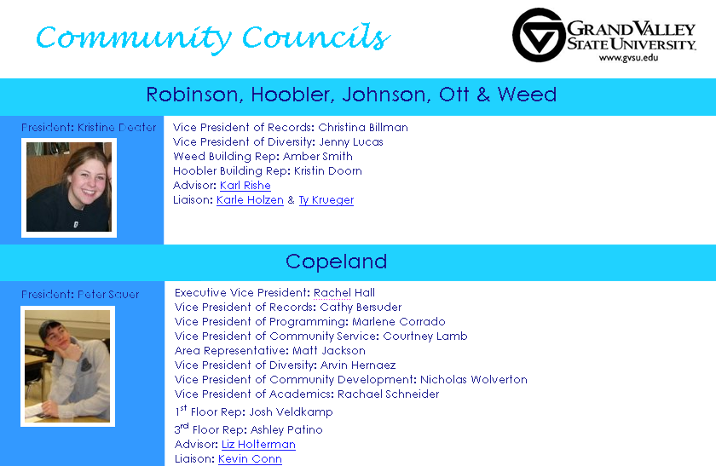

Hypothetical community council page implementing pictures, the RHA logo and color suggestions
- An updated navigation bar is not included in this mock-up but would be needed

Recommendation 2: Provide Site Users with Additional Information
Rationale: The current RHA site does a fair job in providing users with pertinent RHA documents. However, there is some information that is still not available on the website that would be easy to add. This info includes:
- Proposed amendments to the RHA constitution or new legislation
- The minutes of each RHA meeting
- Community council member contact information
- Community council meeting times
- Information on how to become involved in RHA

Implementation Options: Links to proposed amendments and meeting minutes should be added in the "Documents" section of the website. Community council member contact information should be added to the right of each C.C. president (or ideally above a photo of the president as suggested in Recommendation 1). Meeting times could be added on the RHA home page or below each list of community council members on the "Community Councils and Neighborhood Associations" page. Finally, site administrators have the choice of adding a "How to Get Involved" link to the navigation bar, or simply adding a section at the bottom of the home page which answers this question.

Recommendation 3: Add an RHA Calendar
Rationale: Currently, only events for members of RHA are listed, such as conferences they can attend. However, RHA is heavily involved with on-campus activities, such as co-programming with Community Councils and other housing staffs. The events that RHA is involved in on campus should be listed on the website as well as this is good promotion for the organization and will allow students not involved with RHA to become informed of and attend the events, which could lead to increased membership.

Implementation: It is proposed that RHA has two separate calendars on the website, one displaying obligations for members within the organization, such as meetings they have to attend etc…The other calendar will be for the general public and will list events that RHA is hosting campus-wide. Having two separate calendars will provide both RHA members and non-members with the information they need in regards to upcoming events and important dates.

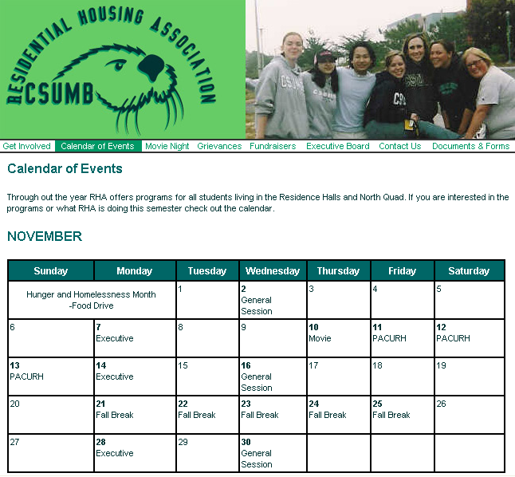

An example of an RHA calendar: California State University – Monterey Bay http://housing.csumb.edu/rha/htm/calendar.html

Recommendation 4: Update the site regularly.
Rationale: A lot of the information on the website is outdated which is not only frustrating for the user, but unprofessional for the organization as well. There are designated links for important pages, but once an individual gets to that page they simply find that the information is from November for example. It does not benefit the user or the organization to have outdated information on the website. It is therefore essential to the effectiveness of this website that the information is updated at least twice a month. Failure to do so will discourage both RHA members and non-members to use the site, leading to a decreased awareness about the organization and its involvement on campus.

Implementation: Most likely, what should be done would be to appoint an RHA officer to update the website on a monthly or even weekly basis. Furthermore, the majority of the updates would be directed towards the calendar/events page of the site. Lastly, any changes in the officers and their roles in RHA would have to be updated as well.

Recommendation 5: Design RHA site based on GVSU homepage style/scheme
Rationale: By designing the RHA site around the color scheme, layout and style of the GVSU homepage, the RHA site can be further branded as an extension or service of GVSU. Currently, the RHA homepage exhibits so much individuality and uniqueness in style that any connection or affiliation with GVSU. Furthermore, by branding the RHA site with GVSU, the reputability and respectability of RHA will increase greatly.

Implementation: Simply, design RHA’s homepage so that it mirrors somewhat the structure and scheme of GVSU’s homepage. Include the same logo, colors and even the layout to some extent. The University of Nevada at Reno is an excellent example of designing a RHA site around the University’s style.

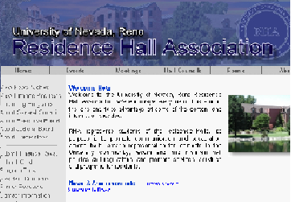

APPENDIX

- GENRE ANALYSIS REPORT

Genre Analysis for RHA Website

Style/Design
- Above all, the best designs are as simple as possible
- The site must be strongly designed around the college’s theme. i.e. school colors, logo, and layout
- The RHA site must be instantly identifiable as part of GVSU based on design alone
- Each page within the RHA site should use the exact same layout and design as the home page—must be uniform!

Navigation
- Left-side navigation bar including: “About Us”, “What is RHA?”, “Upcoming Events”, “Campus Housing”, “Officers” and “Links”
- A quick link back to the RHA home page and the GVSU homepage must be available
- Users must be able to easily identify where they are within the website and where they have been already—however, the smaller and less complex the website, the less this becomes and issue
- Because of the simple layout, Forward and Back buttons are not needed
- Furthermore, a page scroll across the bottom is not needed

Visuals
- A picture gallery of the available housing at GVSU
- A picture gallery of the RHA officers
- The overall visual style of the site should mirror that of GVSU’s home page. i.e. the same logo, color scheme and so forth
- Each page within the website may contain its own unique image or graphic as well to give each page a hint of uniqueness

Layout
- As simple as possible
- The navigation bar should run down the left hand side of the page
- The University’s logo/title bar should run across the top of the page
- The main text of the page should be set aside from the navigation bar and title bar with a plain white background.

Examples
- Seattle University http://www.seattleu.edu/student/housing/index.asp
- Pacific University http://www.pacificu.edu/studentlife/rha/aboutus.htm
- University of Alabama http://bama.ua.edu/~bama-rha/
- Cornell University http://www.rso.cornell.edu/rha/index.htm
- St. Louis University http://www.slu.edu/organizations/rha/

- USABILITY TESTING DATA

New Users
Scenario 1: Find meeting times
Results: Although the user was able to easily find meeting times, those meeting times were incorrect. The website needs to be updated.
Scenario 2: Find events for the month of April
Results: Events listed were out-dated (from November), and focused on current RHA members. Events put on by RHA (instead of for RHA) were not promoted.
Scenario 3: Find contact information for the organization
Results: The user was easily able to find member contact information.
Scenario 4: Find out what RHA is.
Results: Site copy is vague. There was no explanation of how RHA is tied to Community Councils
Scenario 5: Figure out how to get involved in RHA
Results: The website offered no clear way to get involved in RHA (or Community Council) and failed to explain what people in RHA actually do. Overall the website did not do a good job promoting the organization.

RHA Members
Scenario 1: Find out when GLACURH Delegation Meeting is
Results: Because GLACURH is a conference, the user clicked on “Conferences & Business Meetings”. After finding nothing under “Conferences & Business Meetings” the user browsed to “Programs and Events” where he/she found the GLACURH delegation meeting times. Meeting times, however, were out-of-date.
Scenario 2: Find the Executive Board for Copeland Living Center
Results: The user navigated to “Executive Board” where the RHA Executive Board is listed.

- SURVEY

RHA Website Survey

How are you involved in RHA? General Assembly Member RHA E-board Member
Community Council E-board Member Other

Have you visited RHA’s website (http://www2.gvsu.edu/~rha/)? Yes No

If yes, what information were you looking for? ___________________________________

Were you able to find it easily? Yes No Kinda

Was there anything that could’ve made your experience of the website better?

_____________________________________________________________________

How often do you visit the website? Everyday Seldom
Frequently I only visited the website once

Thank You!

