Potpourri
Research Report
Nicole Corely
Lisa Bush
Ryan Walsh

Potpourri’s Goals
Potpourri enlisted the services of the WebSolutions organization with very specific ideas for implementation. They expressed a need to update the appearance of their site as well as modernize and take advantage of certain technological conveniences which would make their site more competitive against other business of this type on the Internet. Some of the more specific topics for which Potpourri has expressed concern include navigation, basic site layout, and color and graphics for the aesthetic appearance.
Potpourri’s Need for Upgrade
Potpourri recognizes the need to be more competitive in the growing electronic commerce aspect of standard business. Their main priorities are the need for a site which is memorable, easy to use, visually pleasing and informative while maintaining a degree of professionalism and convenience. It is important that we consider the cost of implementing such a site, the cost of maintenance and the ease of maintenance because internal personnel associated with the Potpourri Company will shoulder the task of website upkeep.
Situation Summary
After our team at Web Solutions compared and contrasted the website through individual examination and formal genre analysis, several elements were noticeably missing from the Potpourri site which could be implemented at no cost and with minimal effort.
In usability testing, our team had a user that had never visited the site before go through the entire site and see if it was easy to follow. They clicked all of the links on the site and read all of the text on the site. From this experience, we at WebSolutions have recommendations that will make the site more user-friendly and informative. Many of these suggestions include revisions/additions to the text and reorganization of the links for easier site navigation.
The genre analysis gives an overview of the site, information on the writers/developers of the site, audience and users of the Potpourri site, format and organization, level of formality, use of visuals, and range of variation. This gave us a good idea of who uses this site so that we could make suggestions on the site that would directly fit the needs of the site’s primary users. This also gave us an in-depth look at the site so that we were very familiar with not only the company’s history, but also the site’s structure, information and organization.
The user testing revealed that certain conventions increase the comfort level of the user, empowering the user with more confidence. These are the elements that we suggest Potpourri consider implementing in order to satisfy their Internet commerce needs. By adopting these elements, the Potpourri site will maintain its professional integrity while creating a visual experience for the users of their site, resulting in higher customer trust and interest in the company.
Recommendations for Potpourri by WebSolutions
The following recommendations were surmised by a series of user tests, genre analysis and interviews with both members of the Potpourri staff and users of the website. Therefore, these results should accurately reflect a comprehensive approach to our website evaluation and recommendation.
1. Recommendation: Content Development
● The page would benefit from some more distinct separation in content. This would increase user accessibility and allow the user to navigate more efficiently, reading only the information pertinent to his specific needs. Of course, these new pages would require additional navigation, but with simple structural changes, this would be no problem. Per our research, we suggest emphasis on organization by left side navigation. Several other sites use navigation of this type, especially in the Flower Preservation Industry. Often, left side navigation allows the user to scan and browse rather than scroll and search.
● The page would benefit from a more personal touch in the content. The “About us” history section should not be so focused on the hours that the shop runs and more focused on the people behind the shop. Describe more about why the owner loves doing what she does, and maybe include more broad-range quotes. The “about us” and “our shop” sections are pretty similar. They could be merged into one section called “about us” with a history section, a photo gallery section, a testimonial section, etc. As it stands currently, the “our shop” section needs more than just pictures. Perhaps it should include captions for the pictures or a 360 degree photo of the shop.
● The page would benefit from a localized heading/contact information. Specifically, the address: Grand Rapids' Foremost Fresh Flower Preservation Center, 2404 Eastern Ave SE Grand Rapids, Michigan 49507, (616) 245-4962 should be in a separate section, segregated underneath the main heading. This will make it look cleaner, more simple and organized.
● The page would benefit from simplifying the text and information on the home page. We recommend that Potpourri consider restructuring the home page so that the main photograph exists with some of their more current information (promotions, coupons, etc.), along with a short description of the business. The current home page includes frequently asked questions; this should be a page of its own. The following are example of the homepage and a separate frequently asked questions page.
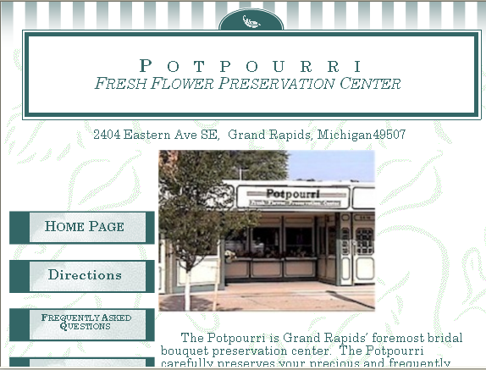
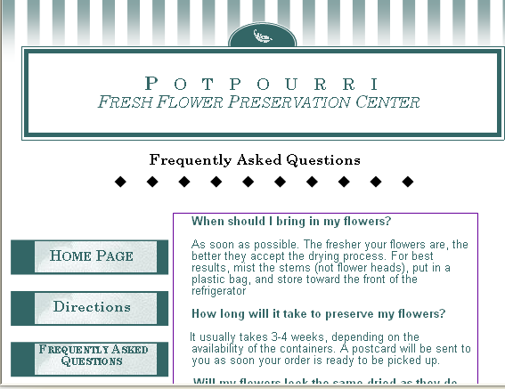
It is important that the content on the page clearly conveys the information and messages that the company is trying to get across to its audience.
2. Recommendation: Aesthetics
The page would benefit from extra attention paid to making it aesthetically pleasing. Currently, the site has very little color variation, green being the base color and the photographs are available in sizes ranging from thumbnails to full size images. This tends to be unattractive to many users and the staff of Potpourri isn’t as satisfied with the sites design as they are with the content. Here is what the Potpourri site currently looks like: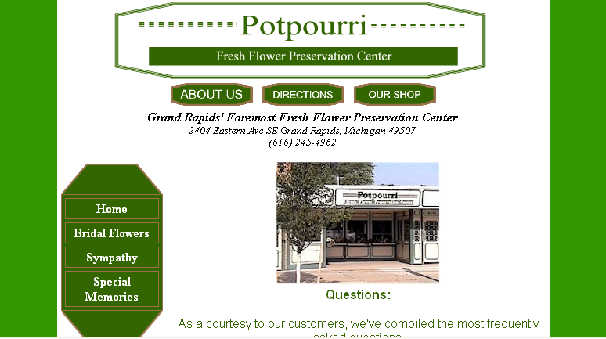
The page would benefit from a more varied color scheme, adding to the visual enticement and overall professional appearance, as they would like the site to reflect the attitude of the company. Perhaps some more floral graphics or motif could enhance the visual appeal of the site, but this is best left to the graphics department as they will have to play around to find an accommodating design. A floral motif would better reflect the nature of the business being portrayed on the site.
Examples are quite prevalent elsewhere on the web by other sites dealing with the Flower Preservation industry and users found this more pleasing and interesting. Not to mention, the appearance seemed more professional. A representative from Potpourri expressed interest in seeing preliminary designs for the new page.
We recommend that Potpourri adopt a more floral centered site. We suggest posting new pictures at a higher resolution with better lighting for ease of viewing. The current pictures are difficult to look at because of the shadows, sharp lights, fuzziness, etc. The font is standard and the graphics are simple. Font and text will be adjusted accordingly but in inclusion of a more varied graphic element might increase user curiosity and enhance usability.
3. Recommendation: Enhanced Navigation
● Site Overall
The page would benefit from more user-friendly navigation. Currently, the page features standard navigation (links, tabs, and buttons) but fails to take advantage of more sophisticated means of navigation. These opportunities might increase accessibility while condensing information and appealing to the company’s vision of a more visual presentation of the site. Image mapping, roll over imaging and pop-up menus are just a few features which could be adopted. Perhaps even split frame navigation in order maintains the sites professionalism. The page would definitely benefit from a greater variety of visual navigation cues as it would alleviate cluttered navigation bars and allow each page to contain a greater amount of information. Tools like image mapping and pop-up menus exist for just this reason. Several other businesses utilize these tools with great success as it adds to the overall appearance by eliminating clutter and condensing information. It makes use of the space available in the best possible way. It also looks more sophisticated and professional.
● Home Page
We recommend that the navigation bar on the homepage be reduced by adding pop-up menus for like information. We also recommend that the initial photograph of the business be mapped to link to the “About Us” page. Driving directions could also be ascertained by clicking a link to Map Quest in order to better facilitate easy to understand directions. If a visitor wondering how to get to the shop can just click on a link that will automatically fill in the address of the shop so that all they have to do is type in their address, they will experience a much greater level of usability from the site.
The site would benefit from re-structuring the home page. If a user finds the homepage frustrating and confusing, they probably will not look at the site for long. The current homepage has some navigation, but the content on the homepage should be divided up into several smaller, more manageable chunks so as to reveal separate pages for the “About Us” segment, “Frequently Asked Questions” segment and the more specific store information (hours, days open, address, ect.). The FAQ section should be moved away from the homepage. It needs to be in its own section along the top, where the “about us” “directions” and “our shop” buttons are. The main page should be a friendly welcome, telling visitors a brief overview of what the company does and what they can expect to find on the site. Also, the inclusion of an on-line order form might be appropriate, depending on the amount of business traffic the business is currently handling. The following is what The Potpourri’s current web site looks like.
4. Recommendation: Ideas for the Future
The company would benefit from considering how it can expand its client base through its website. As the business is located in the center of the Alger Heights district, a diverse ethnic epicenter in Grand Rapids, there is a very large Hispanic population. Currently, the website does not take advantage of the opportunity to reach this percentage of the population by catering to their native language. By appealing to this part of the population, it not only increases goodwill, but also significantly increases the potential for publicity by word-of-mouth. If given the opportunity to advertise on the web, why would one unintentionally exclude a percentage of the population? More people means more business and more business means more money
Bi-lingual businesses, like bi-lingual people, have twice as many options as those who only speak one language. We recommend that after the initial designs are completed, all text is translated and posted as a link to a Spanish site on the home page. If the option exists, someone will use it. It is an easy element to include and it might prove beneficial.
5. Conclusion
The Potpourri website has much to gain by implementing changes to the site’s content, aesthetics and navigation/organization. Considering the audience, the company might also benefit from expanding the site to cater to more than one language.

