WebSolutions Recommendation’s For:

Grand Valley State University
Women’s Lacrosse Team

By:
Alecia Kelly
Caroline Shanks
Kyle Quakenbush

Due: April 25, 2006

The Client and The Need

Our client is the Grand Valley State University (GVSU) Women’s Lacrosse Team. The faculty advisor is Nancy Giardina, but the team is run by its President Laura Hite and officers. The team is coached by Kristine Hite. The women’s lacrosse team’s season starts in January and continues until the end of April. The team has only been in existence for four years. Lacrosse is an up and coming sport that is moving from the east coast to the west. Recently, there has been interest and a need to start a website for the GVSU team.

Currently, there is not a website for the women’s lacrosse team of Grand Valley State University. Most students on campus have heard of lacrosse and are aware that there is a women’s team, but most people do not know much about the sport or the team. This is an issue that the president and the officers would like to address. Therefore, a web page is needed to help create awareness about the sport as well as for the team. This web page would provide information about the women’s team and information about the sport in general. This will increase the knowledge in the student population about lacrosse and the women’s team at GVSU. Laura Hite is the primary liaison for this project. She has a great knowledge about the sport as well as connection to the officers and outside affiliates.

The Research Question

We want to find out how much knowledge people have about lacrosse and the women’s team. We would also like to investigate what type of information would be useful to include on this web page. To do this our research starts with a couple of questions:

- How much knowledge do people have about lacrosse?
- How much knowledge do people have about the women’s lacrosse team at GVSU?
- What kinds of information would be helpful in obtaining more knowledge about the sport and the team?

Methods

Our next step after determining what our questions were was to determine just how we wanted to answer them. We decided that the best way for us to gather the information that we need is to develop a survey and also to conduct personal interviews. Through these two methods we should be able to gather a better understanding of just what the GVSU student body is looking for on the lacrosse website.

The survey that we put together asked the students simple questions so that we could get a handle on what kind of knowledge and interest they have for the sport. We will ask them their age and also what year they are in school. From there the questions will range from questions about how much they know about the sport, are they interested in lacrosse, what they look for in a website, and also what website is their favorite so that we can make this website similar.

The personal interviews will be conducted by our connection to the lacrosse players and officers. The interviews will give us the information of what users will be looking for in the website.

Results

Surveys

For our surveys we were only able get 15 completed. We surveyed the student body equally by year so we should have a good idea of what the whole student body is looking for. Our first question asked the students how much they knew about lacrosse at GVSU. A vast majority of the respondents recorded that they had heard about it. This tells us that there is little knowledge of the team that we have but not a lot.

The second question that we asked was whether or not the students follow GVSU sports. The results to this question were inconclusive because none of the answers have any distinction over the other two. None of the results for the answers stood out.

Our third question asked whether or not the students knew very much about lacrosse. As with the first question a majority of the response said that they did not know very much about it. These went along with our predictions that most people knew of the sport, but do not know the fine details about it.

The fourth question asked the respondents what draws them to a website. The answers were: A) Ease of use, B) Lots of information, C) Attractive, D) All of the above, E) Other. The answer to this question that really stood out was D which means that the students are looking to have all of these elements incorporated into the website. We did have one response in the other category which said that it helps to know that the website is out there. The person that selected this also selected answered D) All of the above, but chose to add the additional information.

Question 5 was eliminated because we decided that the answers to the question would not help us answer the questions that we had. Question 6 asked the students what their favorite website is. The answers to this question would help us determine what we want to make our website look like. The majority of the answers told us that their favorite websites are Facebook and MySpace. While neither of these websites have anything to do with lacrosse or sports in general, we believe that we can still tailor the website to look similar to these.

The last question we asked was whether or not the participants had or are currently partaking in any clubs at GVSU. The results to this question told us that about half of our respondents have been in a club at GVSU. The clubs that were mentioned included athletic, student government, and community involvement. While no clubs stood out over any others, the answers do tell us that clubs are popular among students at Grand Valley.

Overall the survey was very successful in helping us determine what we want our website to accomplish and portray. We know that we must have a lot of information so that people viewing the website will be able to learn more about lacrosse and also what we should make the website look like.

Personal Interviews

We conducted interviews with the president of the women’s lacrosse team, Laura Hite. We also held a small focus group with the officers and several of the players. With the help from the interview and focus group we were able conclude aspects of the team that should be included. Some of our findings are:

- Information about the team: background history of how the team started, what the team is about, and current information about the team.
- Rules of the game and positions
- A discussion board: outsiders can ask questions, players can access valuable information.
- Contact: names, phone numbers, email address, and how to join.

Genre Analysis

Another form of research we did was a genre analysis of other college athletics and lacrosse pages. The two that were specifically analyzed were the men’s and women’s lacrosse pages (separate) from the University of Michigan. Though they are the same sport at the same school, the two pages were very different in how they were organized and presented. The men’s page was very well maintained and contained a lot of valuable information, while the women’s page looked as if maybe it had just gotten up and running, so the main analysis was done on the men’s page. The men’s lacrosse homepage was linked to easily by the main U of M Athletics website.

Content

On the men’s page, visuals were very clear and effective. On the main page, “in-action” photos were used to accompany news briefs, which were listed with dates and links to full stories. Links to places of interest such as championship titles, alumni information, and sponsors were lined up on either side of the page body.

The navigation bar is on the left-hand side of the page, and is the same no matter what link is clicked. Information on lacrosse, a roster, results, schedules, stories, a photo archive, and related lacrosse links are among the list of tools on the navigation bar.

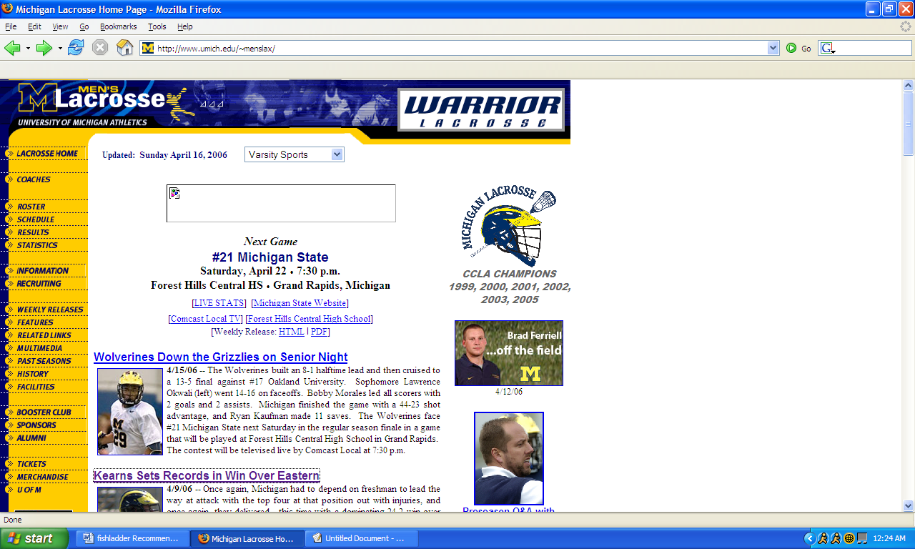

Audience and Users

The first group of users would be students. Whether they are current or alumni, information for either group can be found on this website. Secondly, outside users such as college sports fans would be interested in using this website, so it should contain information such as the history of the sport at the university, links to other athletics, and archives of scores and stories. For the users who are not immediately familiar with some of the players or coaches, information such as the roster would be very helpful. A group of prospective students would also be interested in this kind of information, as well as getting in contact with the coaches and learning more about the sport itself.

Writers

The page is most likely maintained by an experienced technology team who is in close contact with the coaches and captains to ensure that the information is updated and accurate. Having someone reliable and familiar with the site’s content and subject matter will guarantee that no false information is published.

Design and Layout

The website uses the school’s colors and logo. This conveys its pride and connection with the university, even though it isn’t a varsity sport at the school. It stays consistent throughout the site navigation so there aren’t overwhelming colors or graphics. The structure of brief news, parallel photographs, and small info boxes on the side of the page also stays consistent throughout. This ensures that there isn’t an abundance of information that the users will have a difficult time absorbing while using the website.

Recommendations
Recommendation #1

Content

The content of the website should include current statistics and results, as well as archived past results. News briefs would be helpful to those who don’t attend games but like to keep up on the information. Contact information is also crucial in maintaining a credible website for an organization. The navigation bar should include all of (but not limited to) the following information:
- Current roster
- Records
- History
- General information
- Contact information
- How to join (and why to join)
- Current schedule
- Alumni contact (if applicable)
- Photo archive/multimedia section
- Link back to school’s main athletic page

Design

Photographs should not be overwhelming, but would add to the visual attractiveness of the site. Action shots specifically on the main page would look exciting. Other photos could be archived into a photo album. Colors are important for a college-based team. This shows pride and loyalty to the home organization, and is also structural: using one color scheme throughout would be easier and more effective than changing from page to page.

Navigation

The website should be easy to navigate, but not so simple that it’s boring. Side-navigation bars are very effective in keeping sections organized. Mouse-over popup menus can also work here, so that the navigation bar isn’t too heavy with links. This should be kept consistent throughout the entire site so users do not always have to familiarize themselves with new information on every inch of the page.

We also feel that there should be consistency between the Grand Valley’s athletic department’s web page and the women’s lacrosse page. Even though the lacrosse team is a club sport, the reader will have an easer time making the connection between the two pages if it is consistent in its navigation.

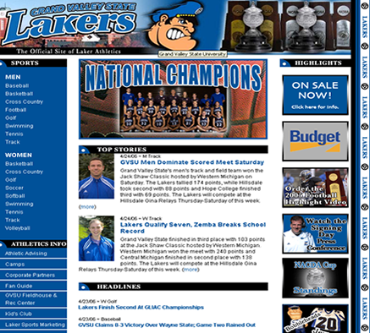

Recommendation #2

Through our research we have found that people know of the women’s lacrosse team but do not know anything about them. We have come up with a web page layout that would be simple in design and easy to navigate. To make the content of the web page simple. We want to give the basics about the team such as:

- When and where they play.
- What their record is.
- How to contact an officer
- How to become involved with the team
- A roster of the team

Recommendation #3

Most people that attend Grand Valley State University have only minimal knowledge about lacrosse as a sport. Our recommendation is to include some of the basics about the game. Examples would include:

- Rules of lacrosse
- Field positions and set up of the field
- The differences between men’s and women’s lacrosse
- A clip of a lacrosse game
- Contacts for youth lacrosse
- Sporting stores that carry lacrosse equipment

Conclusion

Through our surveys and website analysis, we’ve found that a site that has information on the specific lacrosse team, as well as information on the sport would be most effective. If linked to the school’s main athletics site, it would be easily accessible by students, faculty, and sports fans outside of the university - those who are familiar with the sport, or those who aren’t and would like to learn.

If separate pages are to be made for the men’s and women’s teams, they would be linked together with consistent designs and navigation throughout both.

Overall, the website will accomplish the following: provide information for prospective players, provide information for those who want to learn about the sport, give current scores and statistics, and provide player profiles with images, biographies, and game statistics.

Appendix A

Survey

Thank you for taking a minute to fill out this survey for us!

Age: _________ Year: ___________ Gender: ___________

- Do you know much about the sport of lacrosse at GVSU?
  - definitely
  - I’ve heard about it
  - I didn’t know we had a lacrosse team

- Do you follow any GVSU sports?
  - frequently
  - sometimes
  - not at all

- Do you know much about lacrosse in general?
  - yes
  - a little
  - not at all

- What draws you into a website?
  - ease of use
  - lots of information
  - attractive
  - all of the above
  - other: ______________________________________________________

- What types of sports are you interested in?
List:

- What’s your favorite website?

- Are you involved in any clubs at GVSU?
  - no
  - yes: _______________________________________________________

