Websolutions Recommendation Report
fishladder Magazine

Holly McLeod
Anne McKay
Sarah Hammond

Due April 25, 2005
The Client and The Need

Our client is fishladder, a literary publication published by Grand Valley State University’s writing department. The faculty advisor is Chris Haven, but the large student staff does most of the work getting it completed. The magazine is published once a year, in April. This publication currently operates in paper format. Submissions are received on paper, advertising is done via flyers, and the magazine is published only in paper. Recently, there has been an interest in developing a website devoted to this publication in order to increase awareness of its existence, substance, and purpose to members of the Grand Valley community.

Currently, this publication does not receive a great of attention despite its high quality. In fact, most students and many faculty and staff of the university have never heard of the publication – even some in the Writing program itself. This is something the staff and Professor Haven would like to improve. Therefore, fishladder needs a web page so it can be a more accessible and useable publication for its audience. Providing a webpage for this publication would make it easier for students and faculty to learn about the publication. If archives of previous publications were kept online, it would allow student work in the magazine to be featured with a wider audience as well.

Anne McKay served as primary liaison for this project, and since she is on fishladder staff, she has several internal connections with other staff members and Professor Haven, one of main proponents of a website for fishladder.

Research Questions

We wanted to find out what the most relevant and useful information to include on a prospective fishladder website would be. So, in order to do that, we began our research with three questions:

- What information would a user want to see on a fishladder website?
- What kind of users will use a fishladder website?
- What kind of tasks would users of a fishladder website come there to accomplish?

Methods

In order to collect information about the content, design, and navigation needs for a fishladder website, we organized three different types of data analysis – genre analysis, surveys, and usability tests. Our goal throughout each method was to gain insight about prospective users of the website in order to decide what kind of content will best suit the needs of each of the intended audiences.

Genre Analysis
The first analysis we did was a genre analysis. For this type of research, we found other literary publications that had websites from other colleges and universities in order to compare, contrast, and analyze them. In this type of analysis, we were looking for common features across websites, what kind of site navigation strategies were used, and how the overall look and feel of the design of each website worked. As a result of our analysis, we typed up a summary (See Appendix A), and decided that basic site navigation and visual appeal need to be top priorities in our website prototype.

Surveys
The second analysis we did was based on surveys that we handed out to prospective users of a fishladder website. We developed two different surveys (See Appendix B). One was targeted at students in general, and this encompassed those who have been published, those who are looking to be published, and the general members of the university who would like to know what fishladder is. The other survey was targeted at fishladder staff. Each survey had different questions that were unique to the intended audience. We collected and summarized data from almost 20 students and six faculty/staff of fishladder.

Usability Tests
Our final type of analysis was based on usability tests. For this, we formulated a simple usability test plan (See Appendix C). This test plan listed questions for the tester to answer, or tasks for him or her to complete by exploring and navigating two different websites. While testers were trying to answer the questions by navigating the site, we had them speak out loud about what they were thinking, and we took notes on several aspects of how they were performing their task. We timed how long it took them to find information, and the different paths they took to try and find it, and we recorded miscellaneous information about places where they paused or got confused, based either upon our observations or by their “think aloud.” At the end, we let them comment about their general feelings about their overall impression of each site.

Findings

Through our different research methods, we were able to answer our research questions and come up with concrete lists of needs users have, as well as their wants, their likes and dislikes, and subsequently, content that can be catered to them.

What Information Would a User Want to see on a fishladder Website?

- Basic Information about fishladder – the background of fishladder magazine, what it is, what is its purpose, and what it consists of.
- Archives – previous issues of the publication (likely in PDF format) so that those who are interested can read previous entries and download them for their own reading enjoyment at a later time. The most recent version could possibly be in HTML format so users can navigate from submission to submission more easily than through a whole PDF file.
- Submission guidelines – what kind of work does fishladder accept, what the guidelines for submission are, where to submit work, etc.
- Contact information – names, phone numbers, and email addresses of those faculty members and staff responsible for the magazine, where is the office for it located on campus (including a mailing address), etc.
- Staff information – names and brief biographies of current staff members, possibly some information about how to become a staff member. In addition, possibly pictures of the current staff members.

What Kind of Users will use a fishladder Website?

We were able to identify four distinct target audiences that would be using the site. While many of the needs of each of these groups of users may overlap, each group did provide unique viewpoints on possible website content. The four audiences are:

- Students who have been published in fishladder
- Students who would like to be published in fishladder
- Staff of the fishladder magazine
- Other students/faculty of the university who would like to know what fishladder is.

What Kind of Tasks Would Users of a fishladder Website Come There to Accomplish?

- Finding out what fishladder is
- Submitting work online
- Finding out guidelines and procedures for submitting work
- Finding out who is on the fishladder staff
- Viewing previously submitted work
- Finding out how to get a copy of fishladder

Website Layout, Design, and Content Features that Users Liked

- Menus with links – clearly defined and intuitively named links helped the testers find their information quickly.
- Consistent site design from page to page – while not mentioned explicitly, the users made comments about how when menus stayed in the same place and color schemes stayed the same, it made it easy for them to know they were in the same site.
- Helpful navigation – again, while not stated explicitly, the users mentioned how they liked that menus stayed the same and links changed color so they knew where they were.

Website Layout, Design, and Content Features that Users Disliked

- Lots of text – we found that when a tester was confronted with a page full of text to try and read in order to find information, they were immediately resistant.
- Scrolling – any amount of scrolling was disliked. It was especially unpopular when the scrolling had to be done in order to find a desired link. Scrolling to read a story or featured piece of work was okay.
- Unfamiliar terms – one of the websites named a link with a term that is genre specific (“masthead”), and our testers were extremely confused. They were subsequently unable to find needed information when doing so would have meant clicking on the unwisely named link.
- Search engines that do not search – if a search engine only searches part of a site instead of the whole thing, it is not worth having a search engine.

Recommendations

After our extensive research and analysis, we have come up with several recommendations for the content, design, and navigation for a fishladder website.

Site Content

Recommendation 1: Include Content Relevant to Website Users
Rationale: Through our research, we have found that there are several features that all users from each audience agree they would like to see on the website. We have grouped all of these features into one recommendation because the concept behind each type of information is similar. The information users want to see on the website, and that we recommend, are:

- Archives of Previous fishladder Issues
- Current Issue of fishladder
- Magazine Staff
- Submission Guidelines
- How to Get Involved with fishladder
- Ordering Information
- Award Winners
- Links

Implementation Options: Links to all of the listed information can be grouped together on the website. The easiest and most user-friendly way to do this is by arranging them in a menu bar format. The example below illustrates how a significant amount of information can be represented with simple links.

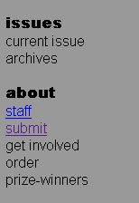

User Interface/Website Design

Recommendation 2: Consistent Design Layout
Rationale: If most of the pages in a website look similar, it helps a user know that they are still at the site, and also facilitates their navigation of the site, since similar objects will be in similar places from page to page.
Implementation Options: This can be done with any design that is chosen. If there is a menu bar on the left and text with an image on the right, with a big title at the top, keep such a design consistent from page to page within the website. Or, a common implementation is that the homepage has it’s own unique design, and subsequent internal pages will have similar designs. Note in the examples below, how different pages in Fugue’s website all have the menu on the left, a title at the top, and the content on each page is in the same location.

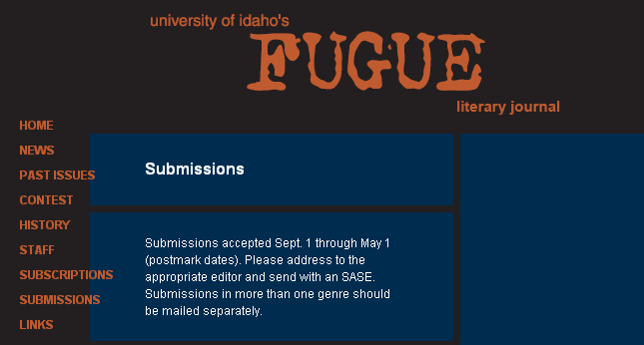

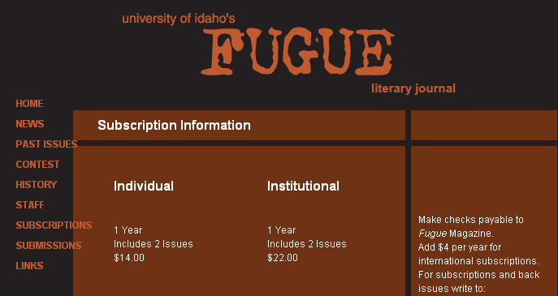

Recommendation 3: Vertical Menu for Navigation
Rationale: While a horizontal menu at the top or bottom of the page could work as well, users in our usability tests seemed to have an easier time finding information when it was in vertical menu layouts. Plus, this type of menu makes it possible to categorize information under headings if necessary.
Example: http://www.uidaho.edu/fugue/
Implementation Options: This menu could be on the left hand side of the page or the right hand side. It would depend upon what other information is decided to be included in the design. Notice how in the example below, information is categorized into “issues” and “about” in the vertical menu.

Recommendation 4: Contrasting Colors
Rationale: Visitors have a hard time with websites that use colors that are so similar that the website is difficult to read.
Implementation Options: Literary magazine websites are often done in safe, conservative colors. Excessively bright and lively colors seemed to turn away users. Two main colors can make up the site; with a third accent color possibly for links or extra information. Colors can be close to one another in the color palette, or far apart, as long as they are contrasting so the website is easy to read. Notice in the example below how the site is easy to read because of the contrasting colors.

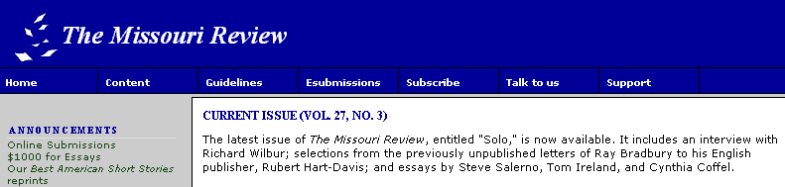

Website Navigation

Recommendation 5: Unique Entry to the Website
Rationale: fishladder is a magazine full of creativity, art, and imagination. Having a website entry page that features student art and guides the user into the site will help emphasize the magazine’s creativity, and distinguish the site and make it more memorable for users. In addition, many users do not know that fishladder accepts art submissions – many believe it is a publication for written pieces only.
Implementation Options: We believe the best way to set this page up is to showcase some of the art that has been published in fishladder. Pieces of writing could be featured as well, but it would not be as eye-catching. Also, our findings have shown that users dislike a large amount of text; so putting such content on an entry page may discourage users from entering the site. In addition, the entry page can serve as a good place to briefly put information about the next deadline date for submission. The example below shows how an entry page can have a unique effect. In this example, clicking on the picture takes the user into the website.

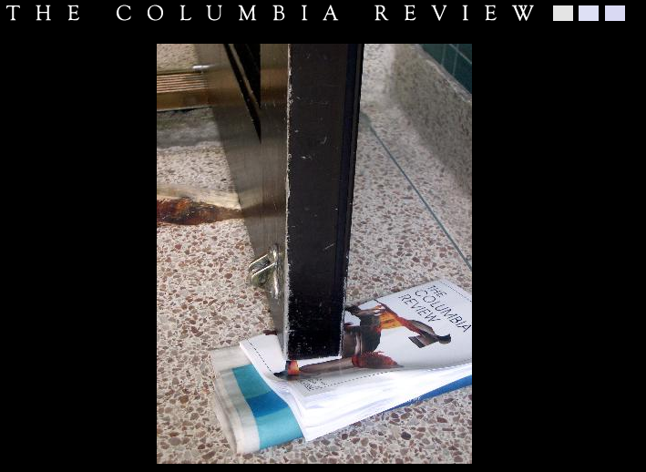

Recommendation 6: Consistent Navigation Throughout the Website
Rationale: This recommendation fits in with Recommendation 2: “Consistent Design Layout” above. However, it also has its own unique meaning in that the links in a main menu should remain the same from page to page. This is yet another way in which a user can keep track of all of his or her options during the visit to the website, as well as where in the website he or she is.
Implementation Options: The example below shows a horizontal menu. This can also be done in a vertical menu, or in any other fashion, such as an image map. Notice, however, that in each section of the website, the navigation at the top remains the same.

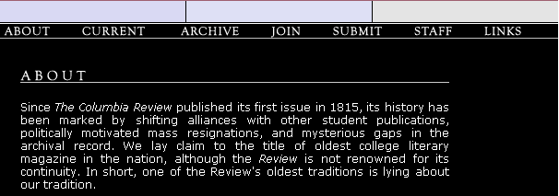

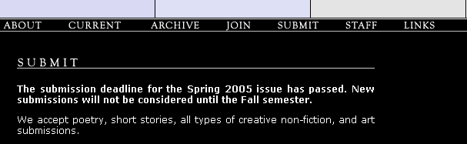

Prototype Example
Pictured below is the final prototype of a website that we have developed for fishladder. It includes all features we have recommended, and we have applied a design concept to arrange all the content that is based upon our genre analysis.

Entry Page
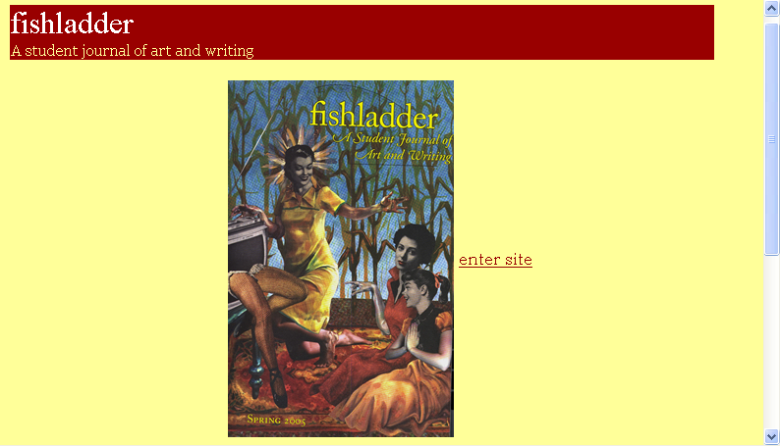

Home Page
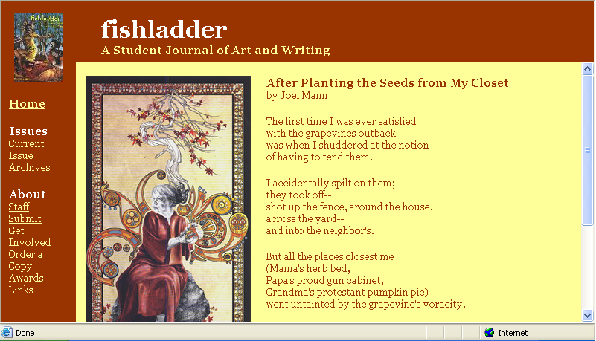

Staff Page
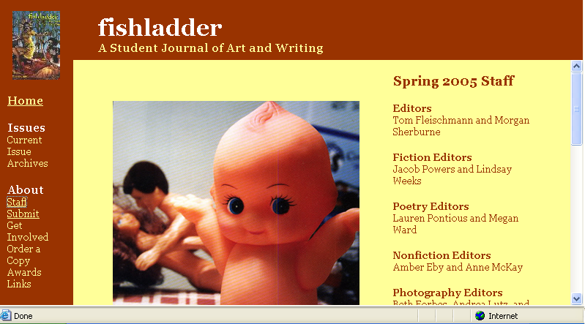

Submit Page
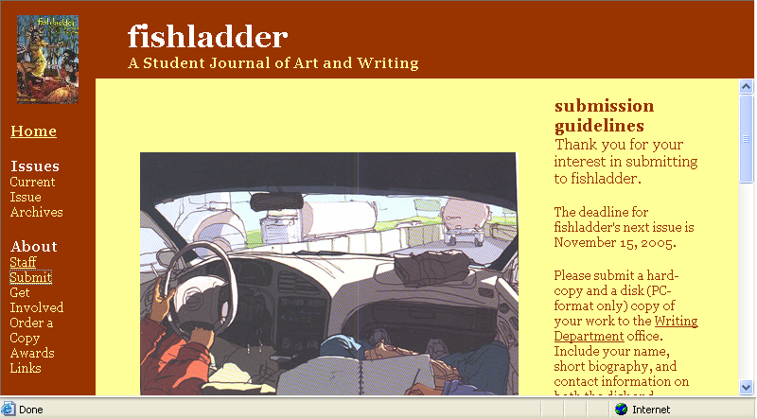

Appendix A
Genre Analysis
Websolutions Project - fishladder
Genre Analysis Results

Websites Analyzed

The Harvard Advocate: http://www.theharvardadvocate.com/about.html
The Allegheny Review: http://webpub.alleg.edu/group/review/index.html
Third Coast: http://www.wmich.edu/thirdcoast/index.html

Common Features Across All Websites

- Editorial Staff Information
- Archives
- Past Issues
- Submission Guidelines/Information
- Links
- Ordering (doesn’t apply to fishladder)
- Awards (does this apply to fishladder?)
- Contact Information
- Featured Work (Monthly or Weekly)

Things and Audience Likes (i.e. Design, Content)

- Clear, easy to read formats with not a lot of text. The image map on the Allegheny site is nice, easy to read, clear, and crisp.
- Also on Allegheny, how they carry the theme throughout the rest of the pages makes for easy navigation.
- Use of a simple, professional color scheme enhances a website (Allegheny and Third Coast)
- Not having to scroll the whole page to get to what we want to see (Allegheny)
- Use of images and/or “logo” of publication

Things An Audiences) Doesn’t Like (i.e. Design, Content)

- Too much text on the Harvard site; it is formidable at first glance
- On Harvard site, links to other parts of the site are too small and hidden (at bottom of page). They need to be bigger and better accessible.
- Having to scroll to get to information we want to see (Harvard and Third Coast)

Appendix B
Surveys
A Proposed fishladder Website

Survey Questions for Students

These questions are about a proposed website for fishladder, Grand Valley’s Literary Publication. This information is being gathered for a writing and web development assignment in Grand Valley’s WRT351 class going on this semester, winter 2005. Your responses will be used to determine what content should appear in a potential website for fishladder. Please enter your responses below each question.

- What year are you in school?

- Have you heard of fishladder? If so, what do you know about the publication?

- What do you want to know about fishladder that you do not already know?

- Would you visit a website devoted to fishladder?

- What information would you look for when visiting a website for fishladder?

- What tasks might you wish to accomplish on a fishladder website?

- Have you ever submitted work to fishladder?

- If you have submitted work to fishladder, what are your thoughts on submitting work via a website instead?

- If you have not submitted work to fishladder and are interested in doing so, would you be willing to submit your work via a website? What do you think of this capability?

- If you were to submit work to fishladder that was chosen for publication, would you be all right with having your published work posted on a fishladder website? State any concerns, objections, or support you may have with/for this feature.

- Would you like to see previous fishladder publications on the website (archives)?

- Please share any additional suggestions you may have for a fishladder website below.

Thanks very much for your input. Your responses are greatly appreciated.
A Proposed fishladder Website

Survey Questions for Fishladder Staff

These questions are about a proposed website for fishladder, Grand Valley’s Literary Publication. This information is being gathered for a writing and web development assignment in Grand Valley’s WRT351 class going on this semester, winter 2005. Your responses will be used to determine what content should appear in a website for fishladder. Please enter your responses below each question.

- What is your role in the fishladder publication?

- Who do you see as the audiences of the fishladder magazine?

- What do you see as these audience’s concerns and needs?

- What can a website do to address these issues?

- What information (be as specific as possible) would you like to see on a website devoted to fishladder?

- What tasks might you wish to accomplish at a fishladder website?

- What are your thoughts on receiving fishladder submissions via a website?

- What do you perceive as the goals of a website for fishladder?

Thanks very much for your input. Your responses are greatly appreciated.

Appendix C
Usability Tests
Usability Testing on websites similar to the future “Fishladder website”

Please ask the testers the following questions pertaining to each website.
Answers listed at bottom.

Usability Testing for Third Coast website (Western Michigan University)
www.wmich.edu/thirdcoast/index.html

- Who is the final judge for the 2005 Third Coast Fiction Award.

- What does the staff recommend doing before submitting a piece in any genre?

- Who is the Copy Editor?

Usability Testing for the Harvard Advocate (Harvard University)
www.theharvardadvocate.com

- Who won 1st place for art, in the Spring 2002? And what is the image of, that won?

- What is the email address for submission inquiries?

- Who wrote “Being Chinese” in the Summer 2003 edition?
Usability Test Results

Date: April 17, 2005
Two Testers: One male, 26 yrs old, “student audience”
One female, 22 yrs old, “student audience”

Third Coast

1. Who is the final judge for the 2005 Third Coast Fiction Award.

Average find time: 30 sec
Path: One tester looked on the home page, another went: contests → 2005
Comments: One tester wanted a “search” function on the site, wasn’t sure where to begin. The other “stumbled” across the answer

2. What does the staff recommend doing before submitting a piece in any genre?

Average find time: 2 minutes
Path: One tester went to “subscribe” link, then to “submissions”; the other went straight to “submissions”
Comments: “It was hidden. I didn’t see any heading titled “recommendations” or any bold text to guide me to the answer. It was included in a ton of other paragraph text. Too hard to find. It didn’t stand out.

3. Who is the Copy Editor?

Average find time: 2 minutes
Path: One tester went through “home” “submissions” “contests” “subscribe” over and over, couldn’t find it, but finally clicked on “Masthead”. One tester systematically went through each link in top menu and found it quicker.
Comments: “What is a masthead?” Both testers had no idea what masthead was, or what it meant. So they did not want to click on it because they didn’t know what was in it. After clicking on it and finding the answer, they still didn’t know what it meant really.

Overall Feelings/Satisfaction:

Both testers thought the site was fine, but fine tune adjustments could make it easier to navigate and find information. One said that they didn’t like having to scroll on the home page to get to some of the information at the bottom. This tester would have preferred this information be listed in a menu at the left side of the page or something for “one click” finding of information so they didn’t have to scroll. The other tester said the site was easy to look at and said the information wasn’t too hard to find. Both said to get rid of “masthead”, since people like themselves who not familiar with the “third coast lingo” might not know what that means, just like them. Also, the links at the top were not underlined until you click them, which gets confusing and makes you think its not a link.

Harvard Advocate

1. Who won 1st place for art, in the Spring 2002? And what is the image of that won?

Average find time: 1 min
Path: One tester went immediately to the “search” button, and upon typing in numerous combinations of “2002”, “Spring”, and “art”, came up with nothing and was frustrated at the search engine. Finally went to archives → art, then past issues → spring 2002 and found it. The other tester finally found where past issues was, then went to spring 2002.
Comments: If there’s a search engine, it needs to work for the whole site, not just to return pieces that have been featured (which is what this one did). Finding past issues and archives finally by scrolling to the bottom of the page was annoying. Should be at the top somewhere.

2. What is the email address for submission inquiries?

Average find time: 10 sec
Path: One tester went to “submit” first, then “inquire”. The other went straight to “inquire”
Comments: This one was an easy one. It was only easier because they already knew that the relevant links you’d need were hidden at the bottom on the page after some scrolling.

3. Who wrote “Being Chinese” in the Summer 2003 edition?

Average find time: 10 sec
Path: Both testers went to Summer 2003, and the answer was right at the top
Comments: None really. This was fast and easy.

4. What is the name of one of the editors?

Average find time: 4 min
Path: One tester took over 10 minutes to find this information. This tester repeatedly went between “inquire”, “about”, “search”, “order”, and “submit” looking for the information and not finding it. Finally saw it under “about”. This tester looked over this information many times without seeing it. The other tester was looking for some type of “staff” link or something like that and was not finding one. Finally stumbled upon answer on the “about” page.
Comments: Both testers agreed there needed to be some type of “staff” link, or at least a similar type link that directed them where to look for the information.

Overall Feelings/Satisfaction:

One tester’s first words when seeing this web page were “Oh, I don’t wanna read this!”. The web page is too wordy, information could be broken into smaller links. Both testers made frequent comments like “I’m not reading all that”. Since all links and information looked the same, could not tell what was a link and what was not.

