

WebSolutions Recommendation Report
for
Habitat for Humanity
Grand Valley State University

Writing for the Web
Winter Semester 2006

Table of Contents

Client’s Communication Goals for the Web Site

Where the Site is Currently

The New Vision for the Site

Site Recommendations

Recommendation 1

Recommendation 2

Recommendation 3

Recommendation 4

Recommendation 5

Concluding Notes

Appendix A

Appendix B

Appendix C

The Client’s Communication Goals for the Web Site

The Habitat for Humanity organization at Grand Valley State University is a non-profit student run organization. The Habitat for Humanity group at GVSU is associated with the Habitat for Humanity of Kent County, but they organize events, fundraisers, and build dates for members of the organization here on campus. The Habitat for Humanity organization as a whole works to build homes at a lower rate for individuals. The Habitat group here on campus currently has a basic website that can ultimately target individuals ranging from club members, current GVSU students, prospective GVSU students, faculty, and even other Habitat branches.

Since the website for the Habitat for Humanity is fairly new, most of the current members have not used the site. When interviewing one of the Habitat members is was clear that she would use the site to check information and to communicate with other members.

In addition to using the website, the Habitat member we interviewed as well as the students we interviewed, they would like to see the site contain information such as upcoming build dates, contact information, group photos, and even a discussion board.

Where the Site is Currently

The Habitat for Humanity organization at GVSU has just recently uploaded a site that they are working on improving. The site has a minimal design concept and lacks the amount of information that potential users would like to see. The site also has a limited color scheme and lacks in the visual appeal.

Currently there is a basic navigation bar on the top of the website. Each section has information but its organization needs improvement.

In researching what the Habitat website users would like to see on the site, we found information that was very beneficial. According to a survey that we conducted on the Grand Valley Campus, the majority of the students would like to see more graphics and more detailed information on the Habitat website.

Currently, the website has sections set up for club information, meeting information, build information, event information, and contact information. However, the detailed information within each section is minimal.

The New Vision for the Site

Our shared goal with GVSU Habitat for Humanity is to make the web site more visually appealing, improve the navigation, add detailed information, and establish branding. Our usability testing, student interviews and Habitat member interviews indicated that these are definite areas that need improvement on the Habitat for Humanity website.

Site Recommendations

Recommendation 1: Layout
Upon brief viewing we feel that the layout of the entire site needs restructuring. Instead of left formatting we suggest centering “Habitat for Humanity” and aligning the navigation bar along with that. Adding a few borders and incorporating graphics and text accordingly will make the layout much more interesting.

Current Habitat Website | Proposed Recommendations
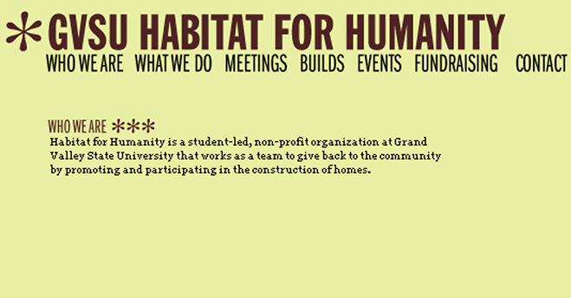

Recommendation 2: Appearance
I think the most significant problem right now is the overall appearance of the site. It leaves much to be desired in terms of graphics, images, etc. We feel that adding these things will greatly attract more users and hopefully get more people interested in being involved with Habitat for Humanity. We want the site to be grab people’s attention and get them excited about the organization. A few suggestions for graphics/images to include are:
- Photos of volunteers working at each project site
- Completed projects
- Members of the organization
- The Habitat for Humanity logo or a specially designed logo for GVSU

Current Habitat Website | Proposed Recommendations

Recommendation 3: Events
Under the events link we feel it would be helpful to incorporate a calendar that will include any upcoming events, meeting times, and other important dates to remember. This way, interested parties can look at the month at a glance and see what is coming up and which days certain events are taking place. Plus it adds another visual element that will move the site away from entirely text based material.

Current Habitat Website | Proposed Recommendations

Recommendation 4: Text
A major problem that we noticed during user testing was the user’s inability to read the information on the site effectively. Currently, it is very small and condensed, which is difficult for many people to read. Making the font larger and possibly double-spaced will help a great deal.

Current Habitat Website | Proposed Recommendations

Recommendation 5: Create Branding
After looking at the results of our surveys, many students wanted their student organization sites to have their own logo, or at the very least, a generic logo, such as the national Habitat for Humanity logo. The MSU Habitat site features the national Habitat logo and combined their own special touches to make it personal to their specific school.

Current Habitat Website | Proposed Recommendations
 | 

Appendix A: Genre Analysis of Habitat Websites

- MSU Habitat for Humanity

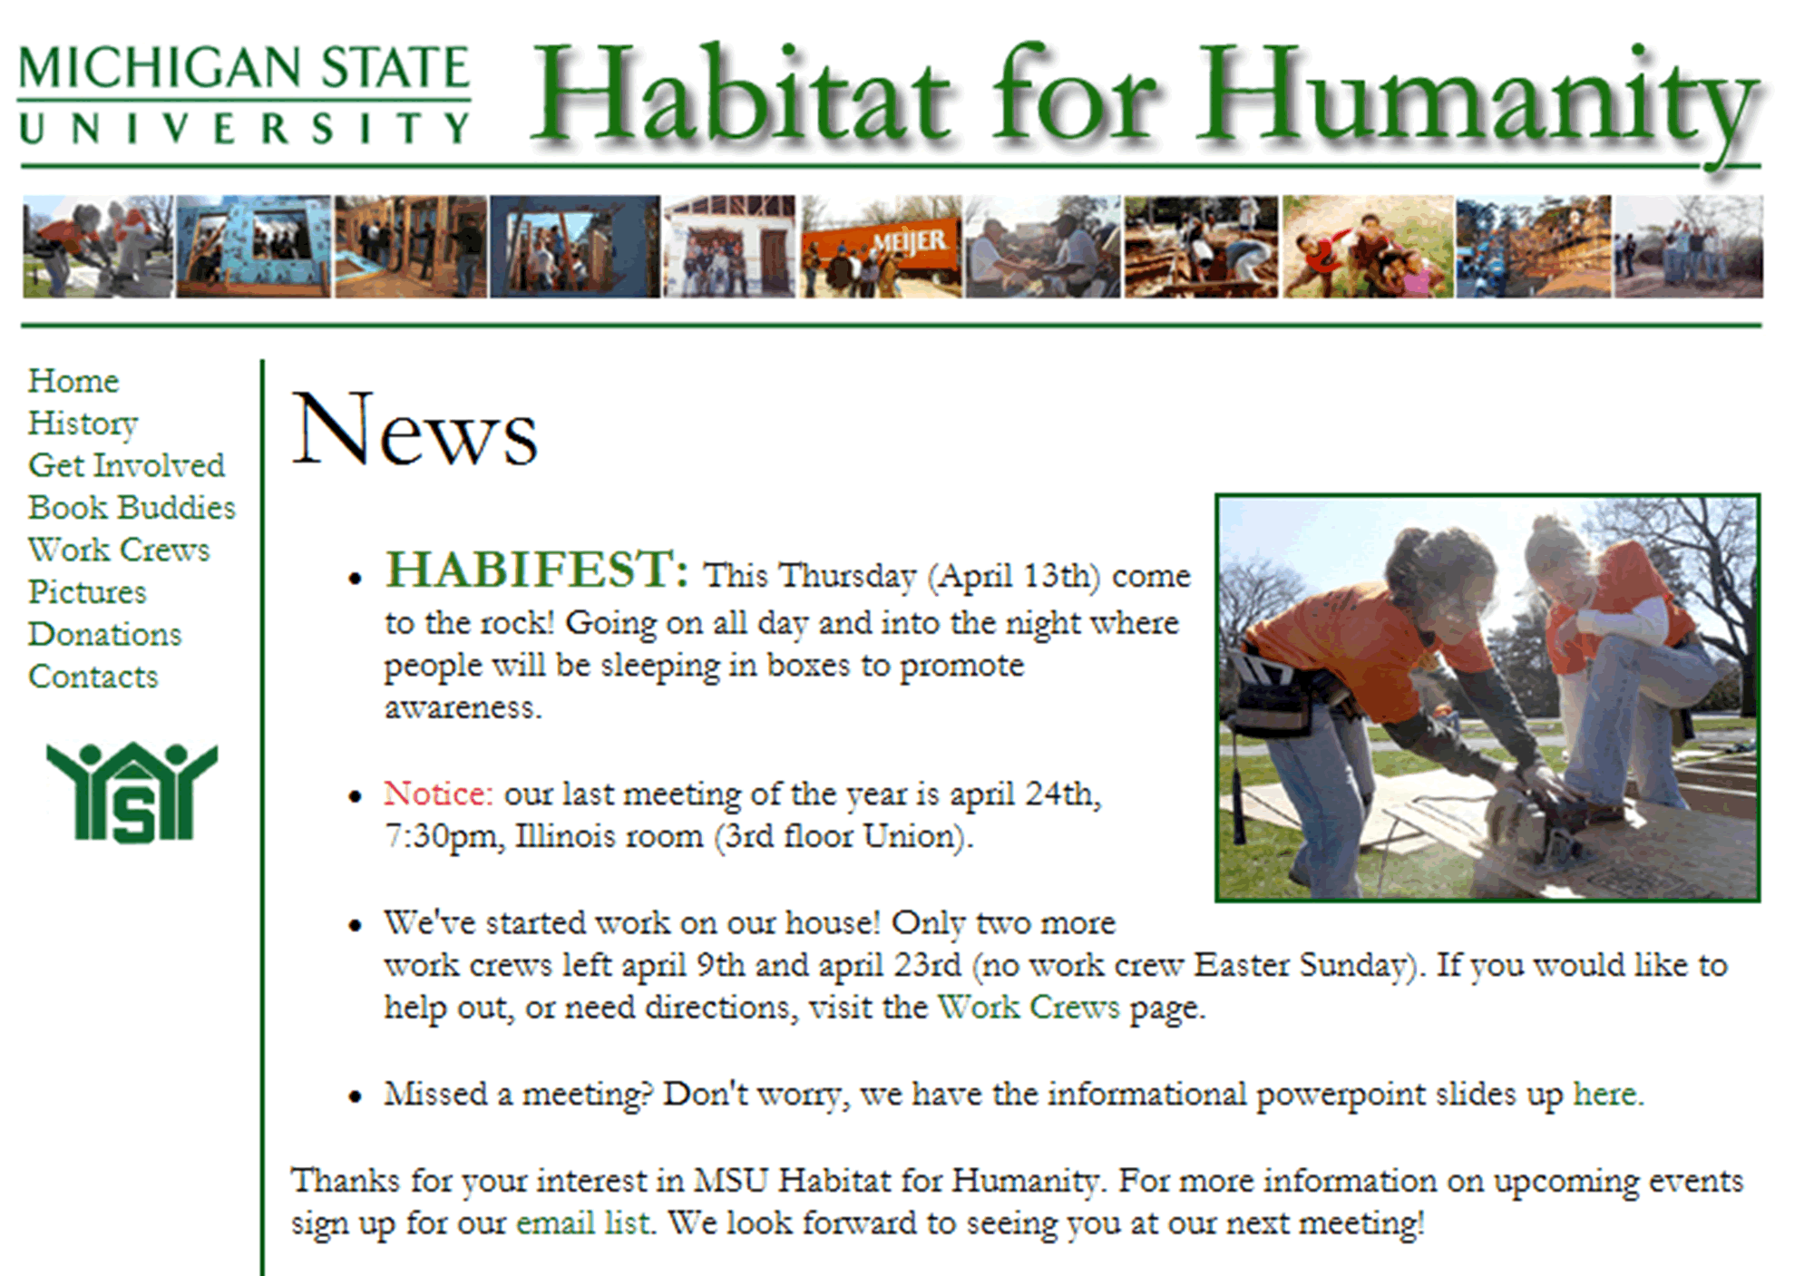

This site contains a gallery of pictures of MSU students helping out Habitat. Not only does State include the Habitat logo, but it also designed its own and displays it on the web site. The heading is large and clear to read. It is green for the MSU colors. It is very obvious what the web site is for. The home site contains the latest news and meeting information. There is a history section that explains how the organization came about. There is a special section where students can send their address to the organization and volunteer to help for Habitat. A section that might only apply to MSU is Book Buddies. The Habitat organization at MSU has a special section for Book Buddies, which is a program where students help underprivileged kids after school learn in fun and creative ways. The Work Crews section gives students information about coming out and helping to build houses. This site also includes a Contacts page which lists where the board members of Habitat can be contacted. There is also a Donations section where people can donate to the organization. This is important because not only people looking to volunteer but people looking to donate can get involved. In addition, donations are very important to this organization! Every section of the site is clearly organized and follows the same format. There is no useless information or clutter on the site.

- U of M Habitat for Humanity

Visual appearance:
Plan and simple, yet professional.
Blue, gray, and yellow
Mostly text, but a few graphics
Information organized into like boxes (chunking)

Features:
- Top navigation bar with main section links
  - Get Involved
  - Committees
  - Contact Info
  - About Us
  - FAQ
  - Photo Album
  - Core utilities
- Drop down menus on each section link
- Roll over images
- Consistent banner at top
- User log in

Logo:
U of M has created a logo that incorporates the parts of the national logo, yet it has the U of M logo in the middle.

- Ferris Habitat for Humanity

Visual appearance:
Red, gold coloring (Ferris colors)
Consistent color flow
Both text and graphics
Consistent Headings and Section links

Features:
- Navigation Bar (including section links)
  - Home
  - Information
  - Our Activities
  - Calendar
  - Executive Board
  - Media
  - Contact Us
- Photos of the Members
- Pictures of events and builds

Logo:
Actually, one of the first things that are noticed on this page is the bright heading, branding the site specifically to Ferris State University. Also there is the Habitat for Humanity logo that is placed underneath the Ferris State heading, branding this site to international Habitat sites.

- University of Minnesota Habitat for Humanity

Visual appearance:
Neutral coloring
Consistent color flow
Equal distribution of text and graphics
Upon each visit, photos on home page change

Features:
- Home page includes upcoming events/announcements
- An informational video on the Habitat foundation
- Meeting dates
- Links include: a calendar, trips, volunteer info, contacts, fundraising, Habifacts (info on the organization, publicity (including magazine articles), and other links.
- Navigation bar is along the top of the page and all the links work

Logo:
This site doesn’t really have its own logo, but it does have the universities logo at the top of the page

Overall, this site gives a great deal of information about the specifics of the organization, especially about how to volunteer. There is even charity events posted that will help raise money for the organization. They include detailed information of these opportunities so that anyone and everyone can participate, including a map and directions to such events. They have a good amount of pictures of volunteers on the work sites and even a video. When I entered the site I was immediately impressed. They have done an excellent job with this site! A good one to model.

- Arizona State University Habitat for Humanity

Visual appearance:
Colors- reds, oranges, and yellows…similar to their schools colors
Not many graphics, one solitary picture in the upper right corner of the home page
Mainly text based

Features:
- Navigation bar on the left
- Links include photos, facts, requirements for beginning participation, their mission statement, officers, and also links to other sites, including Habitat for Humanity International
- Meeting and membership information
- Tax and donation information

Logo:
ASU has the international Habitat for Humanity logo on the top of their home page, but they don’t have their own

Overall, this site has all the necessary information that a non-profit organization’s site should have. It is just missing a balance between graphics and text; it needs more graphics on the home page to draw individuals in.

- Boston University Habitat for Humanity

Visual appearance:
Completely text based
Colors- reds and grays
Plain look, nothing very exciting or attractive to draw people in
No visual aids or graphics

Features:
- Navigation bar on the top of the page
- Links include: Info on meetings, trip building opportunities, other links to similar sites, and contact information.
- The information provided is minimal and simplistic, not many details

Logo:
Appears to be a version of the international Habitat logo, just a variation

Overall, this site could use some work. It definitely needs to incorporate some graphics, which I think would greatly improve the visual appearance. It’s a good start, but needs some improvement.

Appendix B: Survey for Habitat Websites

1) What year are you? Freshman Sophomore Junior Senior

2) When you first go to a web site, what is the first thing you notice?

  - Graphics
  - Heading
  - Body Copy
  - Navigation Bar
  - Other ___________

3) For a student organization, do you prefer the site to be (Circle all that apply):

a. Professional
b. Fun
c. Inviting
d. Informational

- Do you prefer that a student organization have its own logo?
  - Yes
  - No

- What are some of the main sections you want on a web site? (Circle all that apply)
  - Photos
  - Members
  - Club info./history
  - Events/Meetings
  - Home page
  - Links to related sites
  - Contact page
  - Other _________

- Have you heard of Habitat for Humanity?
  - Yes
  - No

- If yes for question 7, what information do you think is important to include on a web site for the organization?

- Would you visit a Habitat for Humanity web site for GVSU?

Thank you for your time! Your answers are greatly appreciated!
*All answers are anonymous
Appendix C: Usability Test

