MEMORANDUM

To: Dr. Sun, Manager
From: Kat Davis, Consultant
Meahgan Pear, Consultant
Date: November 15, 2007
Subject: Pokagon Band Web site Information Design Model (Wireframes and Site Map)

INTRODUCTION

As previously established, the Pokagon Band web site will benefit from valuable recommendations in terms of content management, organization, and overall appearance. Thus, after compiling detailed research and analyses, a complete Information Design Model was constructed. The Information Design Model is the basis for the Recommendation Report, which will ultimately provide the Pokagon Band of Potawatomi Indians with detailed recommendations to improve their existing web site. With this Information Design Model, the content organization and layout are detailed in wireframes and a site map.

WIREFRAMES

In order to display an effective Information Design Model, four wireframes were assembled to represent the basic outline of the web site pages and the different elements on each page. This will help determine how the web site’s content and information architecture should be assembled. The following pages were represented in the wireframes.

- Home Page
- Tribal History Page
- Education Page
- Tribal Government Page

The detailed annotations and wireframes can be found below:

Wireframe 1: Home Page (on the following page)

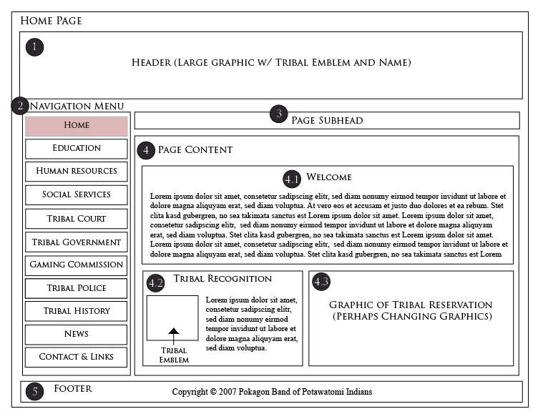

Annotations:

1. This area is the main header, which will be on all of the web site pages. It will be a graphic image (JPEG or GIF) containing the Pokagon tribal emblem and tribal name (Pokagon Band of Potawatomi Indians). It should be visually appealing and contain a background graphic (i.e. the three fires or flames) to represent the traditional Native American culture. This area will be present on each page to maintain web site consistency, allowing the users of the site to know that they have not navigated away from the Pokagon Band web site.

2. This area will serve as the main navigation for each page of the web site. This navigation menu will also remain consistent throughout the site. Each of the pages will be represented in the main menu, and each main navigation link will have a drop down menu (on the home page only) containing sub pages and quick links. Also, the navigation link will be highlighted in a distinguishable color when the user is currently viewing that page. This will allow the user to know what page they are currently on.

3. This area is where a subhead for each page will appear since the main header does not change. Here since the user is on the Home Page the subhead would read “Welcome” in order to let the reader know what page they are on.

4. This area is where the main content for the Home Page will be.

4.1. This area will include a welcome message from the tribe and any additional information to welcome visitors and tribal members to the site.

4.2. This area will include the tribal recognition statement by President Clinton in order to let the users know the Pokagon Band is a federally recognized tribe. The tribal emblem will also be in this section to provide further credibility. This section should be prominent and separated from the general welcome statement to show the prestige of the recognition.

4.3. This area will display various tribal pictures. These pictures should be representative of the tribal reservation, events such as pow wows, or other Potawatomi gatherings. These pictures can be constantly changing in a slide show format or just change when the Home Page is refreshed. Either way, the images will allow the users to get a feel for the Pokagon tribe.

5. This area is the footer of the web site, which will also remain consistent on all pages. It will not be fixed, since the content on all pages will vary in length. However, it will include the copyright acknowledgement and will be updated every year.

Wireframe 2: Tribal History Page

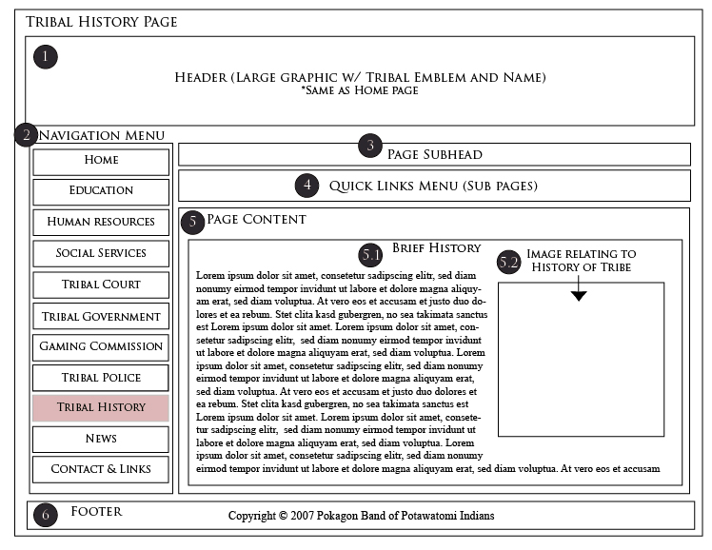

Annotations:

1. This area is the main header, which is the same as the Home Page header. It will be a graphic image containing the Pokagon tribal emblem and the tribal name. Again, this area will be present on each page to maintain web site consistency, allowing the users of the site to know that they have not navigated away from the Pokagon Band web site.

2. This area will serve as the main navigation for each page of the web site. On this page, however, there will be no drop down menu. That is what the quick links/sub page section (section 4) will be used for.

3. This area is where a subhead for each page will appear since the main header does not change. Here since the user is on the Tribal History Page the subhead would read “Pokagon Band History” in order to let the reader know what page they are on.

4. This area is where the quick links or the sub pages will be listed. If the main page (not the Home Page) has quick links (or jump links) those will be listed here. The jump links are links to information that will remain on the current page (i.e. Tribal History Page). The quick links are used because there is not enough information in each category to create an entirely new sub page, but there is enough information where the scrolling must be split up by using these quick links. If the main page will have sub pages instead of quick links, then the sub pages will be listed here. Then the user will be able to click on the sub page link and will be taken to a new page. This section will either have quick links or sub page links. It will also be clearly labeled on each page what kind of links they are. The site map details which pages will have sub page links or quick links.

5. This area is where information about tribal history will be found.

5.1. This area will contain a brief history about the tribe and provide links to further information within the text.

5.2. This area will have images relating to the history of the tribe. Again, these images can be in a slide show format or they can change when the page is refreshed.

6. This area is the footer of the web site, which will also remain consistent on all pages. Again, it will not be fixed, since the content on all pages will vary in length. However, it will include the copyright acknowledgement and will be updated every year.

Wireframe 3: Education Page (on the following page)

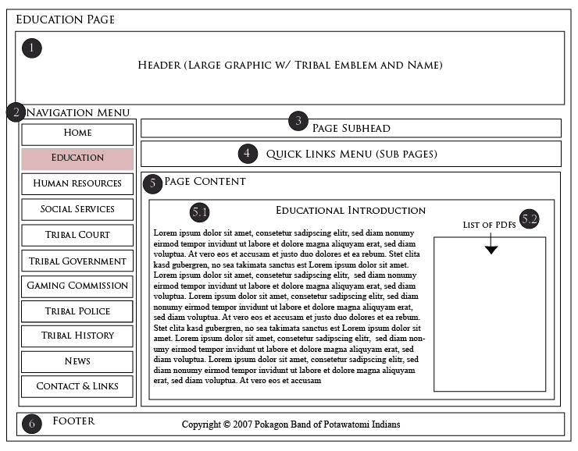

Annotations:

1. This area is the main header, which again is the same as the Home Page header.

2. This area will serve as the main navigation for each page of the web site. On this page, however, there will be no drop down menu. That is what the quick links/sub page section (section 4) will be used for.
3. Here since the user is on the Education Page the subhead would read “Pokagon Education Department” in order to let the reader know what page they are on.

4. Again, this area is where the quick links or the sub pages will be listed. On the Education Page there will be sub pages instead of quick links, since there is detailed information of various Educational Programs. A list of the sub pages can be found in the Site Map section.

5. This area is where information about Pokagon Education Resources will be found.

5.1. This area will contain an overview of some of the services provided by the Pokagon Education Department.

5.2. This area will contain a list of the major downloadable PDF files pertaining to the Education Department. Each sub page off of the Education page will have its own PDF list (since there are so many PDF files available), but on the main Education page only the most frequently downloaded PDF files will be seen. This will make it easier for the users to find information quickly.

6. This area is the footer of the web site, which will also remain consistent on all pages.

Wireframe 4: Tribal Government Page
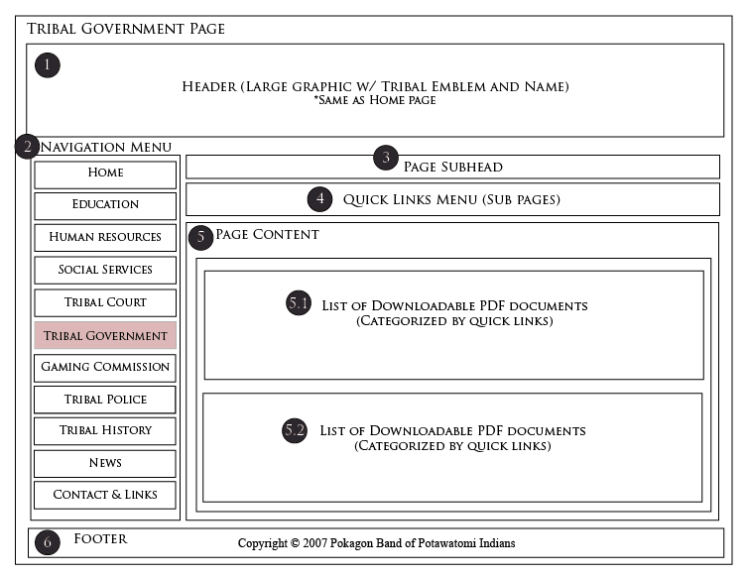

Annotations:

1. This area is the main header, which again is the same as the Home Page header. Keeping this header consistent will also help to provide more graphic representation to some of the pages (like the Tribal Government Page), which consist of mostly text.

2. Again, this area will serve as the main navigation for each page of the web site. On this page, however, there will be no drop down menu. That is what the quick links/sub page section (section 4) will be used for.

3. Here since the user is on the Tribal Government Page the subhead would read “Pokagon Tribal Government” in order to let the reader know what page they are on.

4. Again, this area is where the quick links or the sub pages will be listed. On the Tribal Government Page there will be quick links instead of sub page links, since there is not as much detailed information about the various Tribal Government documents. However, the quick links will take the users to the desired PDF files based on categorizations. A list of the quick links can be found in the Site Map section.

5. This area is where information about Tribal Government will be found.

5.1. This area will contain a list of downloadable PDF files pertaining to specific sections of the Tribal Government. These specific sections will be split up and put into quick links to break up the scrolling. They will not be sub pages because there is not enough information to justify an entire sub page. Rather, with the Tribal Government page, the users only need to be able to access the downloadable PDF forms so they will be compiled in a list under each Tribal Government subsection.

5.2. This area will contain a different sub section list of downloadable PDF files pertaining to specific sections of the Tribal Government.

6. This area is the footer of the web site, which will also remain consistent on all pages. Again, it will not be fixed, since the content on all pages will vary in length. However, it will include the copyright acknowledgement and will be update every year.

SITE MAP

The site map was constructed to show how the recommended Pokagon Band web site will be laid out. The site map is structured starting with the Home Page; which then branches into the main pages, which further branch into sub pages or quick links. The legend on the site map details the color coding and what each page represents.

The complete site map for the Pokagon Band web site can be found below:

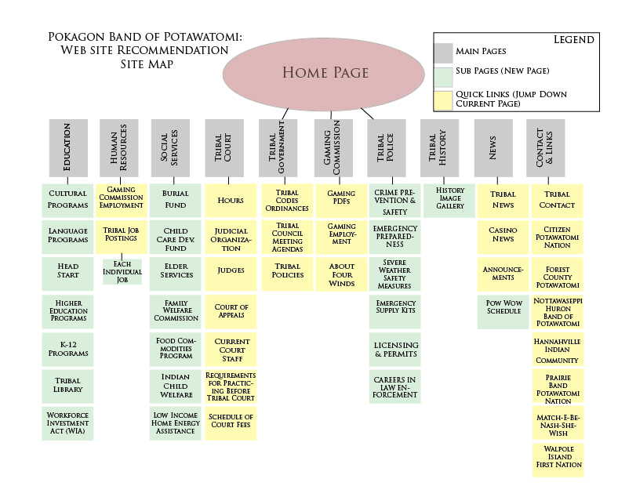

CONCLUSION

As it can be seen, both the wireframes and the site map are essential in order to improve the current layout and content organization of the Pokagon Band web site. Each of the wireframes provides a detailed outline and structure of what the recommended Pokagon Band web site will look like. These wireframes will serve as a basis for the content organization and the final design and layout. The site map is also helpful because it provides the precise layout for the content.

